

**Reservations Department Manual**

Last Updated: 200 April 2024

**INDEX**

Hotel Grand Chancellor Melbourne Limited 4

Hotel Grand Chancellor Melbourne Fact Sheet 5

Room Types 8

VIP Status 9

Market Segments 10

Reservations Abbreviations 12

Special Instructions Guide 15

Special Instructions Guide 18

Creating a New Guest Profile 19

Creating a New Booking 23

Booking Confirmation 27

Types of Bookings 29

Updating an OTA Booking 30

Updating an HGC Website Booking 45

Updating SynXis Booking 47

Promotions 52

Business Travel Partner (BTP) Program 53

Inbound Bookings 54

Group Booking 55

Loyalty Program Redemption Booking 58

Chargebacks & Payment Authorisation Forms 60

Cancelling a Booking 61

Registration Card 63

Pre-Authorisation 64

Commissions 65

**Hotel Grand Chancellor Melbourne Limited**

Hotel Grand Central Limited owns and operates hotels and properties throughout Singapore, Malaysia, Australia and New Zealand.

Incorporated on 13 June 1968, the company listed on the Singapore Stock Exchange in 1978. The founding hotel (Hotel Grand Central) was built by the late Tan Chee Hoe, and his son Tan Eng Teong, who now holds the position of Chairman of the Board.

Hotel Grand Central Limited expanded its hotel and commercial property interest into Australia and New Zealand in the early 1990’s, with commercial property being purchased in Sydney, Australia; and Wellington, New Zealand.

Further expansion occurred with the purchase of several hotel properties in Australia and New Zealand in 1995. Grand Central Management Limited was established to manage the various hotel and commercial property interests.   
  
Throughout Australasia the organisation operates under the Group brand of Grand Hotels International. This umbrella brand enabled an amalgamation of the respective sales and marketing services, and management practices, thereby improving the economies of scale, and providing further opportunities to develop hotel and property management.   
  
In South East Asia, Hotel Grand Central and Hotel Grand Continental subsidiary brands are used, while in Australia and New Zealand, Hotel Grand Chancellor is recognised as the hotel brand.

In Australia, Grand Hotels International has Hotel Grand Chancellor hotels in the major cities of Brisbane, Melbourne, Adelaide, Launceston and Hobart. In New Zealand there are Hotel Grand Chancellor properties in Auckland and Wellington.   
  
Throughout Malaysia from Langkawi to Kuching Grand Hotels International have ten hotels with another in central Singapore.

**Hotel Grand Chancellor Melbourne Fact Sheet**

**General Information:**

* We are a 4-star property offering a wide range of room types, facilities and services to meet the demands of business and leisure travellers.
* The hotel has a total of 160 rooms over 16 floors (Level 2 to Level 17) Level 1 is home to 6 function rooms which vary in size and shape.
* We have a fitness room and roof top heated swimming pool which is open all year round. Operating hours are 7am to 11pm.
* The reception desk is open 24 hours. Guaranteed check-in is 2pm. Check out time is 11am. Guests are welcome to store their belongings inside our luggage room at any time.
* Car parking is located adjacent to the Hotel, with direct access off Lonsdale Street. It is available to Hotel guests at a discounted rate of $35.00 & Corporate guests at the rate of $25.00 per day until 12pm on departure date. The height limit is 1.9m.
* A further $100.00 pre-authorisation deposit (credit or debit card only) as well as a form of photo I.D (i.e. passport or driver’s license) will be required upon check-in. Hotel Grand Chancellor Melbourne pre-authorises all credit cards on the day of arrival to check for validity and sufficiency of funds. Pre-authorised cards are held as security for your reservation and may be utilised by the hotel for any applicable charges, including cancellation and non-arrival fees. The pre-authorised amount is set aside by the credit card company and may affect the available funds balance or spending limit*.*
* Hotel is strictly a non-smoking property. To ensure that the property remains smoke free, any evidence of smoke in a guest room or balcony will result in the guest being charged a cleaning fee of $200.00 and possible eviction from the hotel.
* Hotel has a strict no party policy. Only registered guests (max of 3 people only per room) are permitted to occupy the room between 11pm to 7am. The hotel reserves the right to remove guests if guest is deemed a security risk or nuisance to the property and/or other guests.
* Any guests staying in the hotel and any indicated person or company registered on signed registration card is liable to pay for any part of the invoiced charges, including any undeclared, unsettled and/or damage charges. The guest who signed registration card will also be liable for any costs associated with any false alarm or false activation of any fire and emergency services equipment caused by any person indicated on the registration card.

**Hotel Grand Chancellor Melbourne Fact Sheet**

**Food & Beverage:**

* Footlights Breakfast Restaurant serves a fully cooked buffet breakfast each morning. Times are as follows:

Monday – Friday: 7:00am to 10am

Saturday, Sunday & Public Holiday: 7am to 10:30am

* + Prices for breakfast:

Full Buffet: $29 per person

Continental Buffet: $22 per person

Corporate Breakfast: $22 per person (Full/Continental Buffet)

Children (under 14yrs. old): $14 per child

* + Footlights Breakfast also offers *‘breakfast on the go’* for public & inhouse guests, and for staff. Available from 6:30am to 10:30am – take away only.
* Encore Café & Bar serves dinner, snacks and coffee every day opening at 3:30pm daily. Encore closing times vary depending on demand; however, Front Office team can attend to guest’s orders outside opening hours. Happy hours are from 5pm-7pm every day of the week.
  + Encore Bar also have a promotion of dinner packages both on Groupon & Scoopon. To enter booking, go to

M: Drive > F&B Encore Promotions > Groupon Scoopon Round

* Keep updated of the monthly promotion through EAM’s email update.
* F&B team are in charge of conference rooms once conference manager is out of site.

**Hotel Grand Chancellor Melbourne Fact Sheet**

**Front Office:**

* Sunday sleep in- On going promotion and also available during Public Holidays (subj to avail)

$30 for late departure of 3pm

$60 for late departure of 6pm

* Airport transfer options:

Hotel does not provide hotel shuttle service to and from the airport however below are the recommended services available:

Skybus                               - <https://www.skybus.com.au/melbourne-city-express/>

Bluebird Shuttles             - <https://www.bluebirdshuttle.com.au/>

StarBus                              - <https://www.starbusshuttle.com.au/>

* Hotel doesn’t offer porterage services however front office team can store luggage for hotel guests at any time.
* Concierge area is next to the stairs to conference room and guest can help themselves with brochures and maps. Front office team to assist in booking tours and providing directions to all guests.
* Guest can also book car hire from Hertz through front office. Forms and brochures are available at the reception desk.
* Business Centre is available from 7am to 11pm daily for hotel guests. If scanning, faxing and coloured printing is needed, front office team will assist. Fee will depend on the number of documents.
* Taxis can also be booked through front office. Rodrigo offers flat rate of $70 going to airport with $5 commission fee to the staff booker. Otherwise, can also book through 13CABS.

**Room Types**

**Classic Queen Room (1 Queen Bed)**

One queen bed, ensuite bathroom, sitting area with two tub chairs and coffee table, private walk out “Juliet” balcony and work space. The Classic Queen room is a comfortable way to spend that short business trip or casual getaway in Melbourne.

**Classic King/Twin Room (1 King Bed OR 2 Single Beds)**

Includes either one king size bed or two king single beds, ensuite bathroom, sitting area with two tub chairs and coffee table, private walk out “Juliet” balcony and work space. The Classic King/Twin room is a comfortable way to spend that short business trip or casual getaway in Melbourne.

**Superior Queen Room (1 Queen Bed)**

Smart and well appointment the Superior Queen room has been recently refurbished and contains one queen bed. Ideal for the corporate traveller it offers a dedicated work space, sitting area with two arm chairs and coffee table, featuring newly renovated bathroom with luxurious rain shower, new LCD TVs with limited Foxtel channels & your own private walk out “Juliet” balcony.

**Superior King/Twin Room (1 King Bed OR 2 Single Beds)**

Smart and well appointment the Superior King/Twin room has been recently refurbished and contains either one king size bed or two king single beds. Ideal for the corporate traveller it offers a dedicated work space, sitting area with two arm chairs and coffee table, fully renovated bathroom featuring deluxe rain shower, new LCD TVs with limited Foxtel channels & your own private walk out “Juliet” balcony.

**Premier King (1 King Bed)**

Spacious and stylish, the room offers a king size bed with modern work area and chaise lounge, 40” LCD TV and a brand-new bathroom featuring a relaxing rain shower and modern fixtures. All Premier King Rooms are front facing offering views over Lonsdale Street and the surrounds. A perfect getaway for the more discerning traveller.

**VIP Status**

Below is the table with explanations relative to the VIP status:

|  |  |
| --- | --- |
| **GUEST STATUS** | |
| **VIP1** | VIP PER GRAND CENTRAL SINGAPORE |
| **VIP2** | VIP PER GRAND CENTRAL NZ |
| **VIP3** | VIP PER EXEC MGMT |
| **VIP4** | GC REWARDS MEMBER |
| **VIP5** | CHANCELLOR CLUB MEMBER |
| **VIP6** | COMPLAINT GUEST |
| **VIP7** | REGULAR GUEST (3+ STAYS) |
| **VIP8** | RACK RATE GUEST |
| **VIP9** | GROUP GUEST |
| **VIP10** | CORPORATE GUEST (1 TO 3 STAYS) |
| **VIP11** | LEISURE GUEST (1 TO 3 STAYS) |
| **VIP12** | WHOLESALE GST - CONF RATES |
| **PRE** | PRE-REGISTER |
| **NON** | NON-OCCUPIED ROOM |
| **BLACKLIST** | BLACK LISTED GUEST |

* The majority of OTA bookings you will input are VIP 11 (Leisure Guest)
* Bookings from the GDS (e.g. Telstra) are all VIP 10

**Market Segments**

**C1**

* Direct corporate bookings (email or phone) where the company does not have corporate rates negotiated with the Hotel. When creating a new company in HMS, please make sure you insert the market segment.

**C2**

* Bookings made by an agent on behalf of a corporate client who may or may not have rates set up with the Hotel, these can be booked direct via email/phone or via the GDS.
* Also includes consortia rates (10% OFF BAR) for our preferred agencies (FCM, AMEX, Radius etc.). When receiving chargeback please check thoroughly for company details and update booking in HMS should they have a negotiated (C3) rate already. If the company name is in HMS but market segment is C1, leave agency details on booking and DO NOT update to company profile.

**C3/C4**

* Corporate booking that has a negotiated rate setup with the Hotel. Bookings can come direct via email/phone or via the GDS. C3 (small accounts), C4 (medium accounts)

**CSPECIAL**

* High volume corporate negotiated accounts, i.e. Telstra, Australia Post & GHD. Bookings can come direct via email/phone or via the GDS

**INT CORP**

* Bookings which has come via HGC web or an OTA which have 1 PAX staying in room from Sunday – Thursday nights

**INT LEISURE**

* Bookings which has come via HGC web or an OTA which have 2 PAX staying in room on all nights and 1 PAX staying in the room on Friday & Saturday nights

**DOMESTIC LEISURE**

* Domestic wholesale bookings booking via allotment & free sale (FLIGHT CENTRE GLOBAL PRODUCT, Travelliance, Entertainment Card, Qantas Holidays etc.) where wholesale rates are negotiated.
* Also encompasses direct BAR and promotional rates bookings made via email/phone where the purpose of the guests stay is leisure and loaded under “Private Booking”.

**GOVT**

* Bookings from State & Federal government departments
* Bookings can come direct via email/phone, via AOT – Government channel (Federal Government) & the GDS
* Some government entities have negotiated corporate rates with corporate inclusions. Always check company details in HMS under tab7 to see if negotiated rates are in place and if so, include the inclusions on the booking.

**Market Segments**

**CONFERNECE**

* Bookings for guests attending a conference within the Hotel

**INBOUND FIT & GROUP**

* Bookings coming from an agent for a guest or group traveling to Australia from an international location
* Rates are negotiated with two tiers (Asia & Rest of the World). Many inbound agents have allotments with the Hotel with FIT travel.
* Inbound group booking with 7 & below rooms booked will be Inb FIT.
* Inbound group booking with 8 & more rooms booked will be Inb Group.

**Reservations Abbreviations**

**Room Types:**

|  |  |
| --- | --- |
| **Definition** | **Abbreviation** |
| Classic Queen Room | CLASQ |
| Classic King Room | CLASK |
| Classic Twin Room | CLAST |
| Superior Queen Room | SUPQ |
| Superior King Room | SUPK |
| Superior Twin Room | SUPT |
| Premier King Room | PREM |

**Payment Methods:**

|  |  |
| --- | --- |
| **Definition** | **Abbreviation** |
| All Charges Back | ACB |
| Awaiting Authorisation | AA |
| Credit Card | CC |
| Direct Bill | DB |
| Free of Charge | FOC |
| Pay Own Account | POA |
| Pay Own Extras | POE |
| Pre-paid | PP |
| Permanent Authorisation  (Permanent Authorisation on file for the year in M: Drive) | **PERM AUTH** |

**Reservations Abbreviations**

**Payment Methods – Internet Bookings:**

|  |  |  |  |  |
| --- | --- | --- | --- | --- |
| **Booking Agent** | **Payment Method** | | | |
| AOT | DBA | | | |
| Booking.com | PP | | POA | |
| Entertainment Card | CC | | | |
| Expedia | CC  (Expedia Collect Bookings) | | POA  (Hotel Collect Bookings) | |
| Flight Centre | DBA | | | |
| GDS Bookings | POA | CC | | AA |
| GC / CC Rewards Redemption | DBC | | | |
| HGC Website | POA | | | |
| HotelBeds/Travelcube | DBA | | | |
| Hotel Reservation Service (HRS) | POA | | | |
| LIDO | DBA | | | |
| Need It Now | DBA | | | |
| Qantas/Hooroo/Jetstar | CC | | | |
| Revato | PP | | POA | |

**Reservations Abbreviations**

**Inclusions:**

|  |  |
| --- | --- |
| **Definition** | **Abbreviation** |
| Breakfast for 1 | B1 |
| Breakfast for 2 | B2 |
| Breakfast for 3 | B3 |
| Baby Cot | C |
| 2 Course Dinner | 2D |
| 3 Course Dinner | 3D |
| Early Check-In | ECI |
| Internet/Wi-Fi | I |
| Late Check Out Fee | LCO |
| Meals | M |
| Newspaper | N |
| Parking | P |
| Rollaway Bed | R |
| Upgrade | U |
| Pre-Authorisation | Z |

**Others:**

|  |  |
| --- | --- |
| **Definition** | **Abbreviation** |
| Business Travel Program | BTP |
| Do Not Unblock | DNUB |
| Long Stay Guest | LSG |
| Estimated Time of Arrival | ETA |
| Estimated Time of Departure | ETD |
| Regular Guest Amenities | RGA |

**Corporate Booking Inclusions:**

|  |  |
| --- | --- |
| **Inclusion** | **Abbreviation** |
| Wi-Fi, Newspaper, 1x 400ml water | INW |
| Breakfast for 1, Wi-Fi, Newspaper, 1x 400ml water | B1INW |

**Special Instructions Guide**

The layout of all instructions must be as below and all instructions must be in uppercase:

**PAYMENT METHOD RATE (INCLUSIONS) + ADDITIONAL ITEMS POE – BTP **PERM AUTH\*\***

**ROOM TYPE**

Sample:

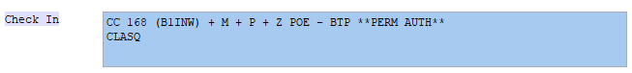

* Abbreviations should be in **alphabetical order** (e.g. ***B1INW***)
* The rate doesn’t require a ‘$’ sign.
* For multiple nights
  + with same rate:

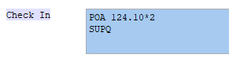

* + with different rates:

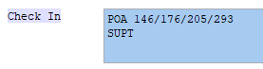

**Special Instructions Guide**

* Anything in brackets are **included** in the rate:

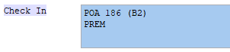

* + $186 rate includes room and breakfast for 2
* Any additional charges are to be added **after**:

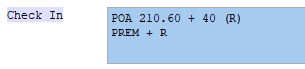

* + Guest to pay extra $40 rollaway bed fee (not included in $210.60 rate)
* Multiple payment method special instruction:

Must be separated by ‘**//’**

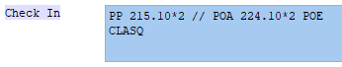

* + First 2 nights had been prepaid and the last 2 nights are still to be settled.

**Special Instructions Guide**

**Chargeback:**

If company sends an authorisation or chargeback, it is important to update the following boxes:

**Check In**: Special Instruction + Room type

**Check Out:** Late Check Out Time, Chargeback Restrictions, Email address for invoice, Pre-authorisation/Bond Information

**Posting:** further information regarding posting, charges, payment & instructions

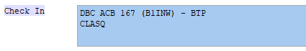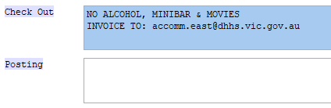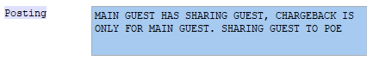

**Special Instructions Guide**

**Remarks – Pop-Up Notes:**

This will be the notes that will initial pop-up when folio is opened. Important information and notes are added here by both FO & Res.

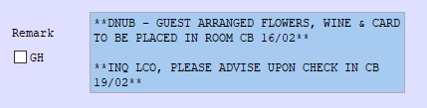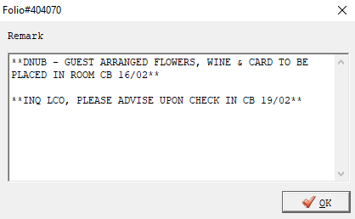

* Each note added on remarks should include staff initial and date when notes had been added.
* Any corresponding update on initial note added should be added under the note.

**Creating a New Guest Profile**

Step 1: Open HMS

* Click the Guest & Company > Guest
* Type in guest name and click 
* Name format will always be **LAST NAME, FIRST NAME, TITLE** and always in upper case

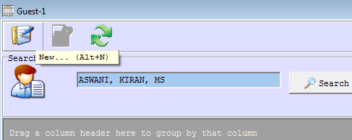

* Fill up necessary information:

(1) Main

|  |  |
| --- | --- |
| * Status | * Telephone / Mobile Number |
| * Full Name   (LAST NAME, FIRST NAME, Title) | * Email Address |
| * Gender | * Country and City if known |

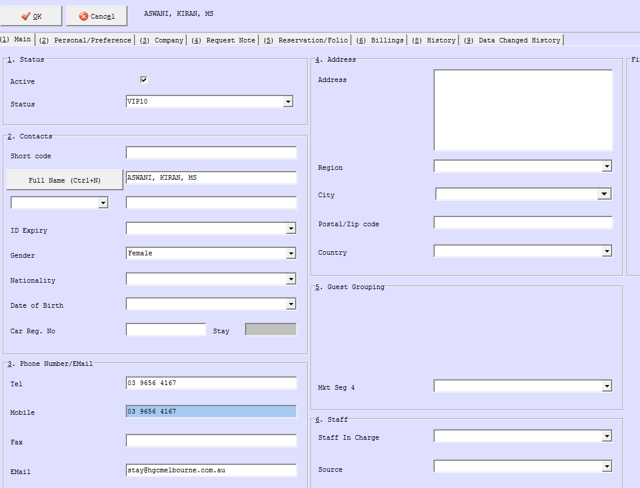

**Creating a New Guest Profile**

(2) Personal/Preference

* Credit Card Details
  + Right click and choose Add Credit Card Info
  + Fill up with guest’s/booker’s credit card details and press next.

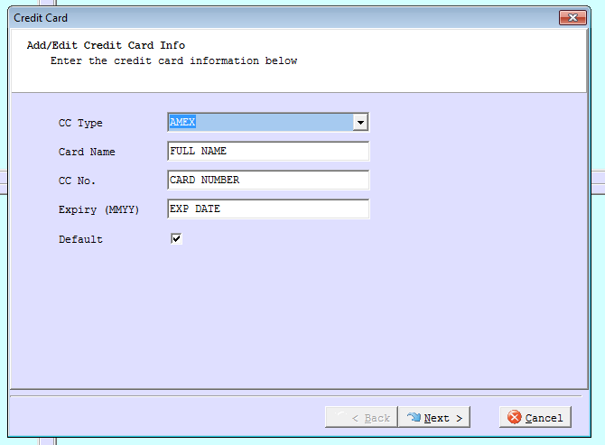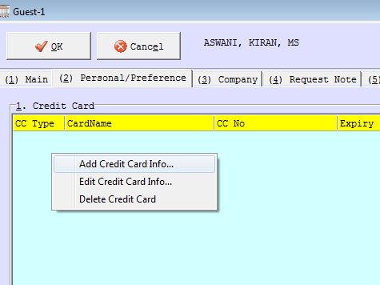

**Creating a New Company Profile**

Step 1: Open HMS

* Guest & Company > Company
* Check first if company is already in HMS.
* Type company name and click search, if not existing yet click: 

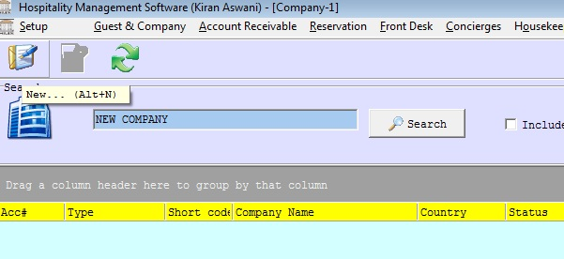

**Creating a New Company Profile**

* Fill up necessary information:

(1) Main

|  |  |
| --- | --- |
| * Status (VIP10) | * Contact Details (Tel, Fax, Email & Website) |
| * Short Code (optional) | * Staff in Charge & Source |
| * Name | * Billing & Mailing Address |
| * IATA Number (only for agencies, not for corporate companies) | * Market Segment *(refer to pages 7-8 of this manual)* |

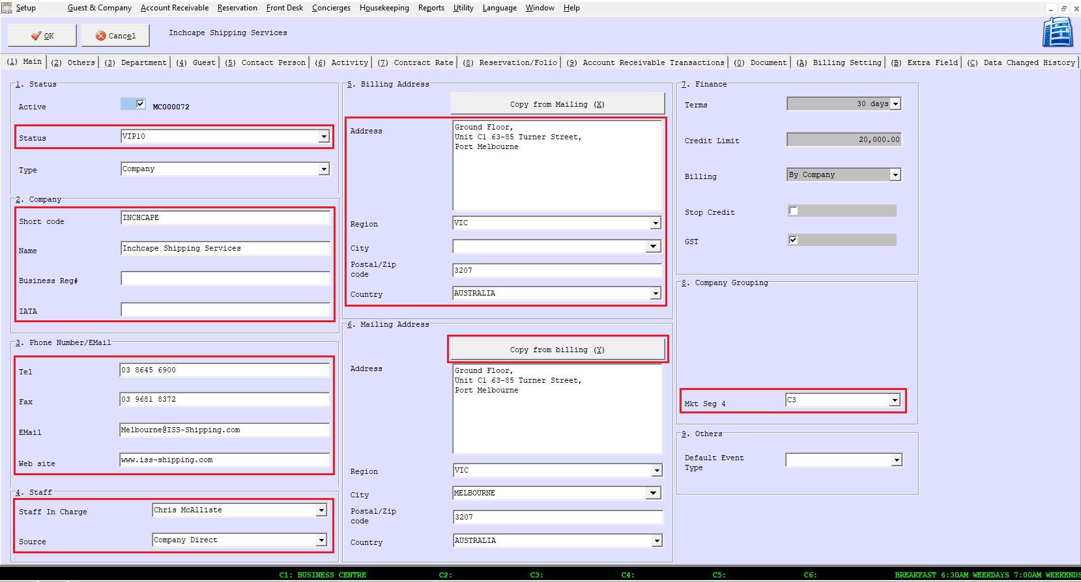

**Creating a New Booking**

**Private Bookings**

Step 1. Get all the important details from guest/booker:

* Date of stay
* Room type (bedding configuration)
* How many pax
* Check if guest is GC Member and ask for membership number to confirm

Step 2. Check Availability & Rate

* On HMS
  + Reservations > Rooms Availability > (3) Room Type Tab
  + Adjust date range if needed
  + Check for rates and open Rate Calculator (M: > Operations > Reservations > Promotions & Calculators > Promotional Calculator) to apply discounts. This should also be available on every desktop of FO Reception Computer.
  + Ensure to apply additional 10% off to the rates for GC Rewards members.

Step 3. Provide Rate

* Always offer BAR & SAVER Rates and explain difference between the two rates
* We can match rates found online only if we are able to find it.
* Corporate guests can utilise corporate rates for personal stay.

Step 4. Create the booking

* Press Alt + C or click 
* Fill up necessary information:
  + Guest – locate if guest has an existing profile.
    - Type in guest name in correct sequence (Last Name, First Name) and ensure it is spelled correctly.
    - Press F2 or . New window will pop up with list of guest profile. Choose correct profile by matching contact number/company name. Edit profile and add/update credit card number to guarantee booking.
    - If no existing profile found, create new profile by clicking  and ensure all details are filled up:
      * VIP Status
      * Full Name (Last Name, First Name, Title)
      * Contact Number
      * Email (for booking confirmation purposes)
      * Credit card details
      * If GC Member and no existing profile yet, add GC Membership # & ensure VIP status is VIP 4

**Creating a New Booking**

* + Company Name – locate if guest’s company is already in the system
    - Use *‘Private Booking’* as company if booking directly over the phone or through email.
    - Create company if not yet in the system
  + Room Type – best rate type applicable will be in red coloured font. If multiple rate available, ensure to click on the best rate code applicable to the rate that had been quoted.
  + Check In date
  + Check Out date
  + Number of Adults & Number of Children (only if applicable)
  + Rate type
    - Click on  and list of rate code will pop up. Choose the best rate depending on the rate you’ve quoted to the guest.
  + Contact Person
    - Get the booker’s name and contact number and add it under contact person’s details
    - If the guest who will be staying is the same person making the booking, type *‘self’* under contact person’s detail
* Once all details are filled up, press  twice
  + Mkt Seg 4 & Source will automatically be filled up

Step 5: Update the newly created booking

* Guest booking will pop up and the following details needs to be updated:
  + Special Instructions – update Check in & Check Out Instructions. Refer to Special Instruction Guide (page 12) for the correct sequence.
  + Additional Items if any Add-Ons/requests were added and input/adjust fee under sales row if necessary
  + Update Rate under **(3) Room Tab** for private bookings

Step 6: Send booking confirmation to the email address provided.

**Creating a New Booking**

**Corporate Bookings**

Step 1. Get all the important details from guest/booker:

* Date of stay
* Room type (bedding configuration)
* How many pax
* Check if guest is GC Member
* Check if works for a company that has a contracted rate with us (only if they have not mentioned it yet)

Step 2. Check Availability & Rate

* On HMS
  + Reservations > Rooms Availability > (3) Room Type Tab > check room type availability
  + Adjust date range if needed
  + Open Company Profile and check contracted rate. Check also if company has credit facility.

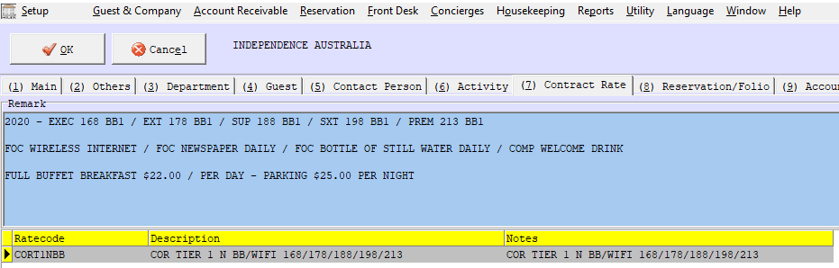

Step 3. Provide Rate

* Always advise inclusions such as breakfast (depending on their contract), Wi-Fi, Newspaper, 1x 600ml water each day, complimentary welcome drink upon arrival (except government & Shipping companies), 10% off bill at Encore (except shipping companies).
* We can match rates found online only if we are able to find it. If we match lower rate that guest has found online, ensure that corporate inclusions are also added, as this is part of their contract. When matching a lower rate for existing corporate companies, use the corporate rate code and adjust rate manually.
* Corporate surcharges apply for special events.

**Creating a New Booking**

Step 4. Create the booking

* Follow same instruction in creating booking for private booking
* Locate same company details you’ve pulled out when you checked rates
* Rate Type
  + Choose the rate code that is in red coloured font

Step 5: Update the newly created booking

* Guest booking will pop up and the following details needs to be updated:
  + Special Instructions – Check In, Check Out & Postings. Ensure that if there is chargeback for specific booking made to update booking with chargeback details and restrictions.
  + If guest is a regular guest, ensure to add VIP/Corp Guest on the Additional Items
  + Rate will automatically update with the contracted rate of company however this needs to be updated if surcharge applies.

Step 6: Send booking confirmation to the email address provided.

**Booking Confirmation**

* HGCM electronic booking confirmation link: <http://mail.dataarc.com/em/forms/subscribe.php?db=674785&s=316158&a=39400&k=ACMc2tAry-tuHSckjaPNzI11tP3bRxshw0d7gi9iq20>
* Booking confirmation are only used if guest directly book through the hotel via phone call or email which the hotel staff will create on HMS.
* Different booking confirmation template will be used for inbound bookings which is available in reservations email templates.
* Multiple bookings under same guest name and details can be sent in 1 confirmation up to maximum of 3 rooms only. If more than 3 rooms booked, multiple booking confirmation needs to be created and sent.
* Every booking confirmation made and sent, confirmation email will also be received on reservations email. Ensure to double check all information entered are correct before sending.

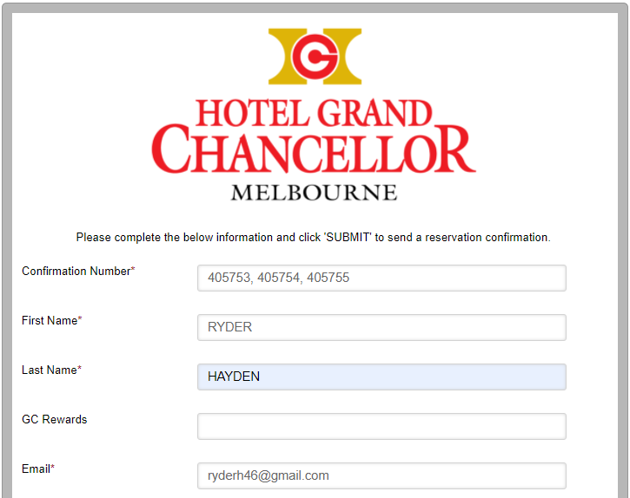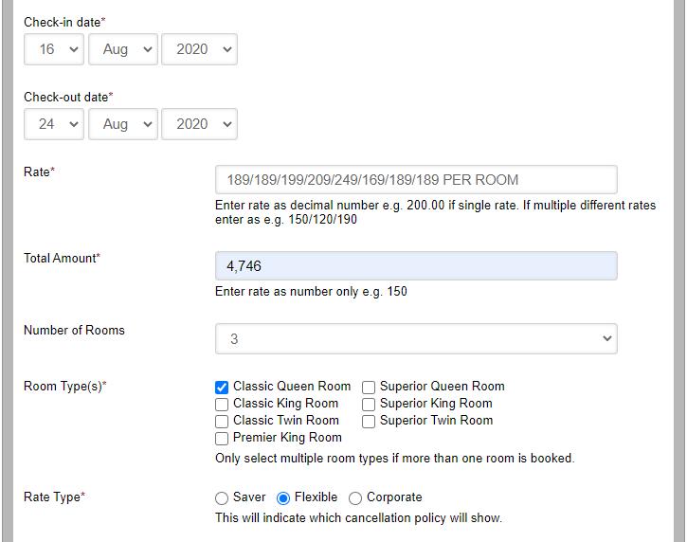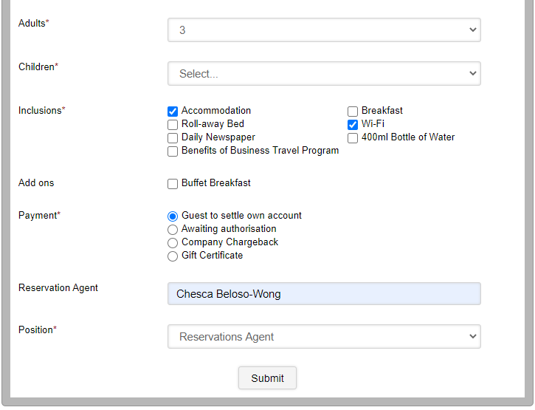

**Types of Bookings**

**OTA Bookings**

Online Travel Agent Bookings are online companies whose websites allow consumers to **book** various travel related services directly via Internet. Below are some of the 3rd party agents or OTA companies:

|  |  |
| --- | --- |
| * Booking.com | * HRS – Hotel Reservation System |
| * Expedia | * Qantas / Hooroo / Jetstar |
| * Flight Centre Travel Group | * Revato |
| * HotelBeds / Travelcube |  |

**Private / HGC Website Bookings**

These bookings are reservations made by guests or consumers directly to the hotel’s website or through phone call or email.

**GDS**

For GDS bookings they are all POA unless stated in the special remarks that it is chargeback. If it states charge back you have to write AA, as then we know we are awaiting chargeback paperwork for that reservation. Once we receive the chargeback it is changed to either DB or CC.

**Inbound Bookings**

Domestic wholesale bookings. Usually bookings from tour operators and travel agencies. Below are some inbound companies

|  |  |
| --- | --- |
| * ANZ Sky Tours | * McDermott’s Coaches |
| * ATM – Australia Tours Management | * NCT Tours |
| * H.I.S. Oceania | * New World Holidays |
| * Holiday Pacific | * Trans Orbit |
| * Maxim Tours | * Wing on Tours |

**Updating an OTA Booking**

Step 1: Locate the booking on HMS by typing guest name

Step 2: Once located, read and understand carefully the booking before updating in HMS. Ensure to match booking/reservation confirmation ID from OTA email booking received to the Voucher# on HMS.

Below is the information needed to be updated:

Tab **(1) CORPORATE:**

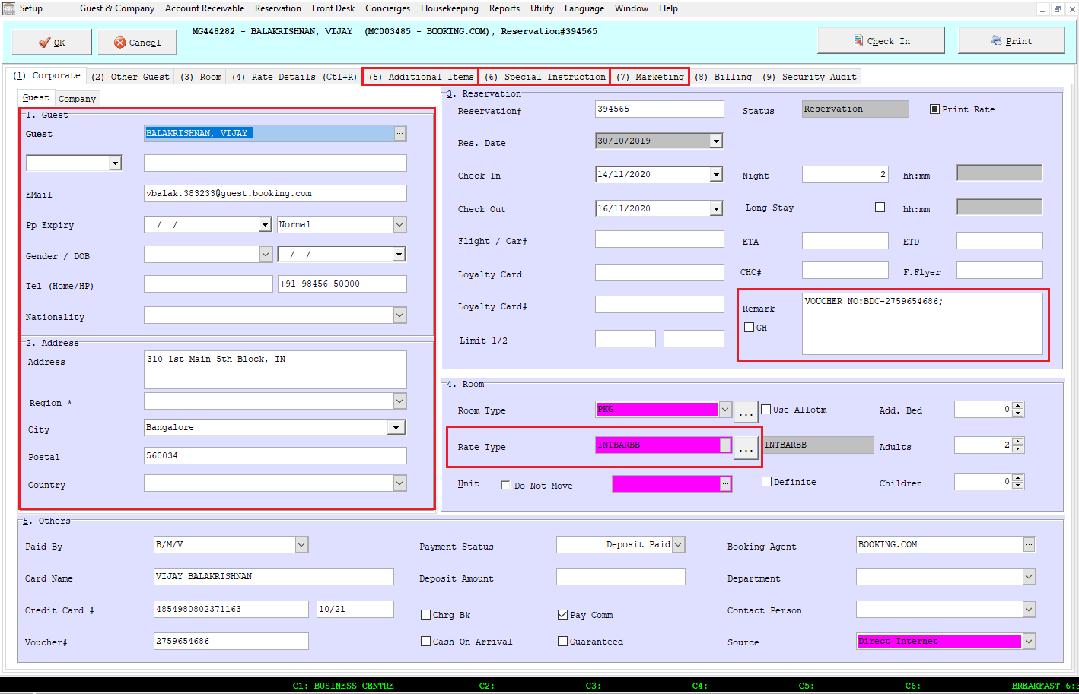

# Guest Profile

# Remove unecessary information

# &

# Add guest addt’l requests

# Rate Code

**Updating an OTA Booking**

Tab **(5) Additional Items**

* All guest requests to be added in this section.
* If breakfast is not included in the rate and is an add on to the booking, it will be added under additional items with the correct rate per person.
* If breakfast is under Inclusive Items, this means that the breakfast rate is already inclusive of the rate that the guest is paying.

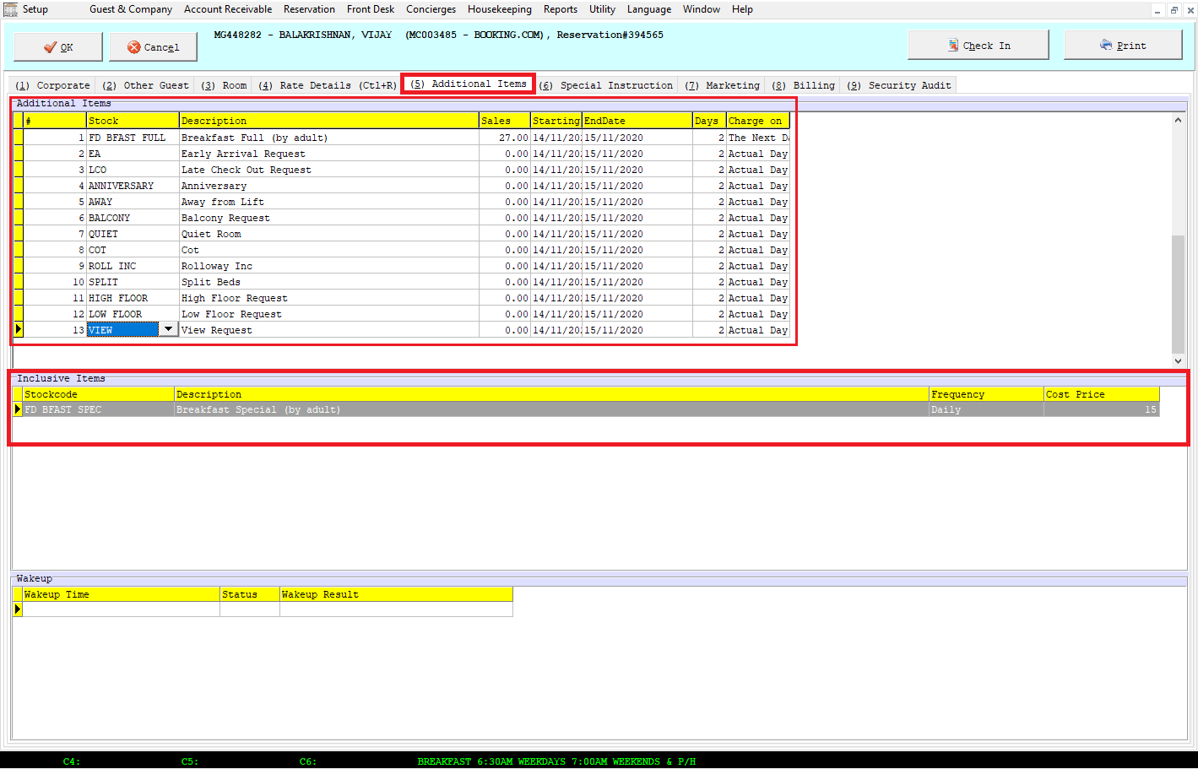

# Items that area already included on the rate that guest is paying

# Guest requests OR add- ons that will be paid on check-out

**Updating an OTA Booking**

Tab **(6) Special Instruction**

* Check In: delete unecessary information and update accordingly with correct payment method, rate, inclusions & room type
* 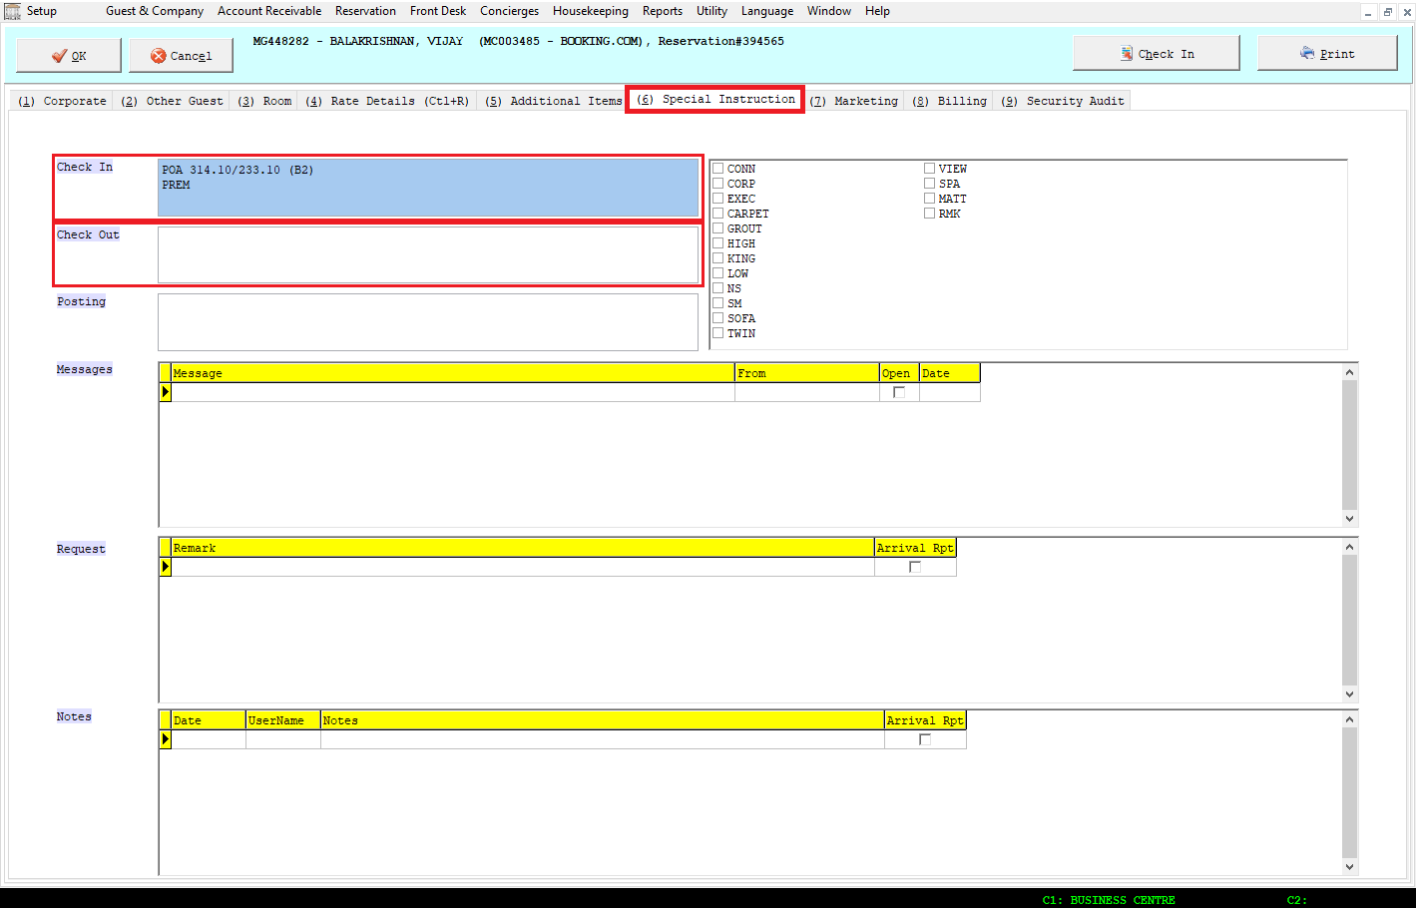Check Out: delete uncessary information and update accordingly with chargeback restrictions & tax invoice email address if applicable.

**Updating an OTA Booking**

Tab **(7) Marketing**

* Update with the correct market segment accordingly. No booking should roll as ’Int Pend’.

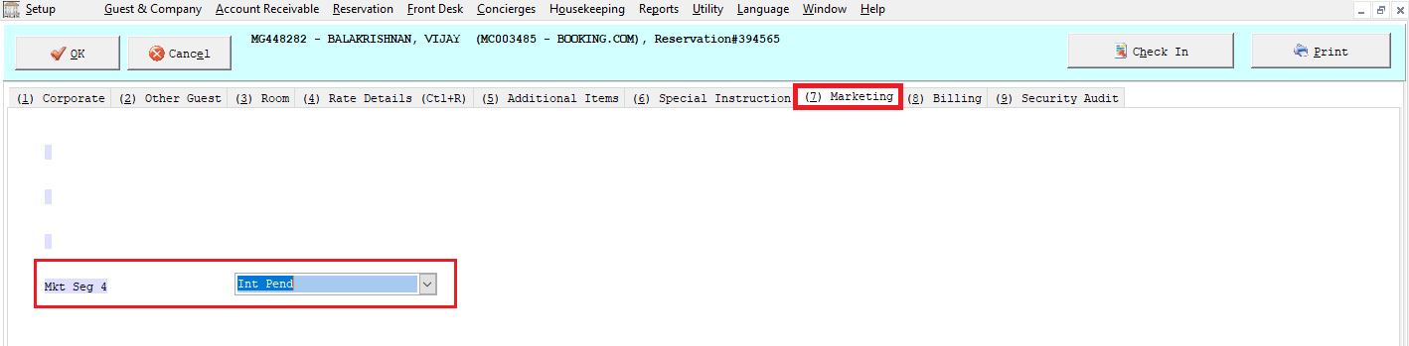

**Updating an OTA Booking**

**Booking.com**

* If booking is Non-Refundable, payment method will be PP and credit card supplied should be charged on the same day of booking or prior to check in date unless it is a same day booking.
* Same day booking will automatically be POA (regardless if it is a Non-Refundable booking) & notes should be added on remark section of HMS regarding this.
* If booking is General, payment method will be POA and will be processed upon guest’s check in.
* Below is the important information to look at:

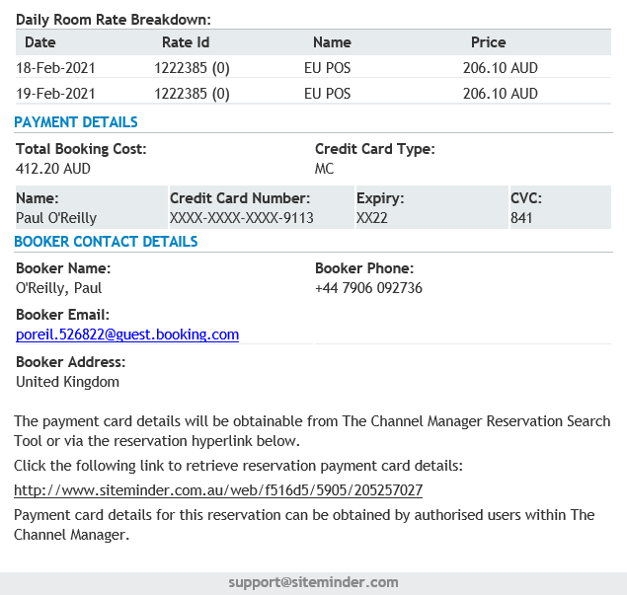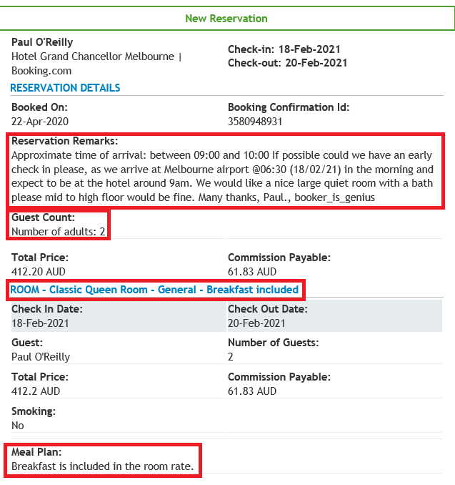

# Guest requests

# Number of guest

# Cancellation policy

# Breakfast Information

# Rate breakdown

# Siteminder link to obtain CC details

# Guest’s details

**Updating an OTA Booking**

**Booking.com**

* If the booking is for 3 Adults, the Rollaway Fee is included in the nightly rate. Must add ‘Rollaway Incl’ in Additional Items
* If breakfast is included and 3 guests are selected. Both the Rollaway and Breakfast is included in the nightly rate. Must add ‘Roll incl.’ in Additional Items.
* If breakfast is under ‘Add-Ons:’, breakfast is not yet included in the rate. Must add ‘*FD BFAST FULL’* in Additional Items and update rate under Sales to current breakfast rate offered.

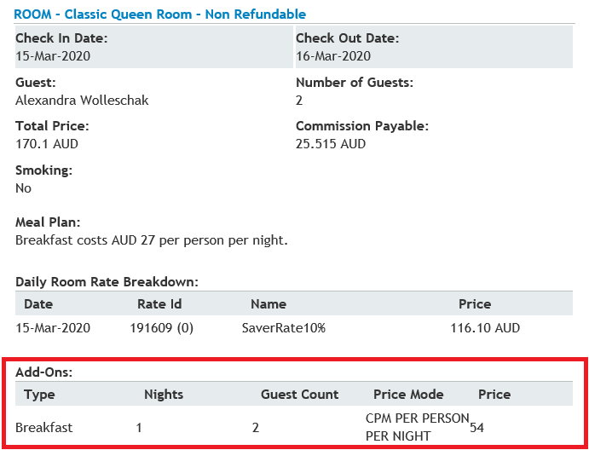

* Additional Item:
  + On the booking, it was for 2 guests. In Additional Item, the rate you will be putting will be the breakfast rate of each person hence it is $27 which will be $54 for 2 pax.
* Special Instruction:

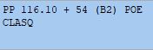

**Updating an OTA Booking**

**Expedia.com**

* If booking is Expedia Collect Booking, payment instruction will be CC.
* Obtain VCC on Siteminder and save on M Drive > Reservation Chargebacks > Year > Month > Date of check- in. Save it with guest’s last name & folio number.
* If booking is Non-Refundable, rate code should be ‘INTSAVERRO’ or ‘INTSAVERBB’
* If booking is Bed & Breakfast, rate code should be ’INTBARBB’
* If booking is Room Only, rate code should be ‘INTBARRO’
* Below is the important information to look at:

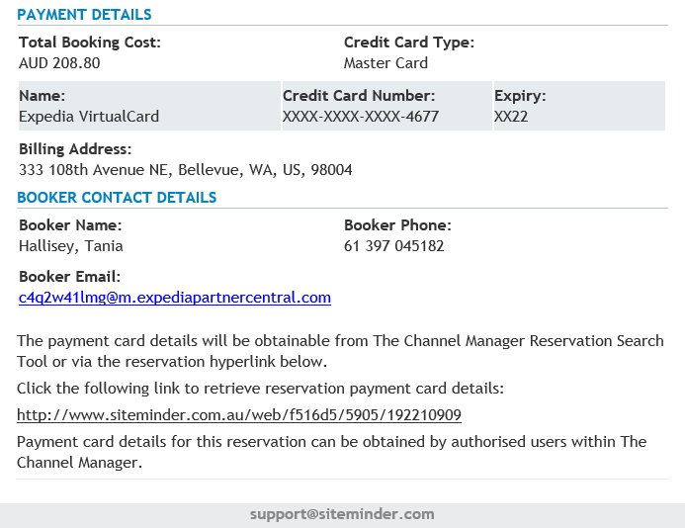

# Guest requests

# Number of Guest

# Cancellation policy

# Rate breakdown

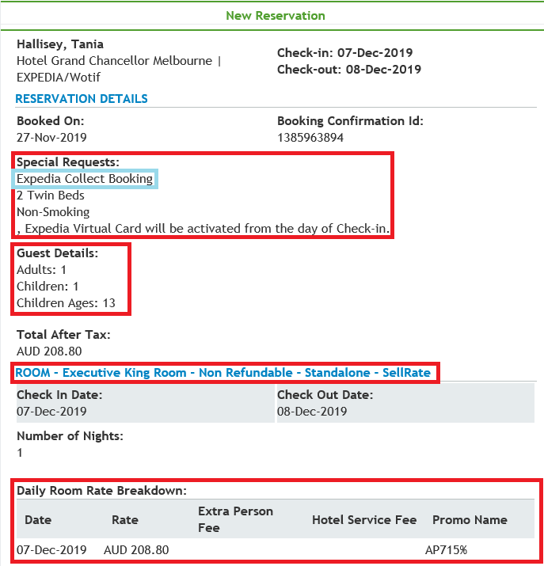

# Payment Method

# Siteminder link to obtain CC details

**Updating an OTA Booking**

**Expedia.com**

* If booking is Hotel Collect Booking, payment instruction will be POA on arrival. No prepayment needed.
* Company profile and Booking Agent on HMS will be updated to EXPEDIA.COM – DIRECT

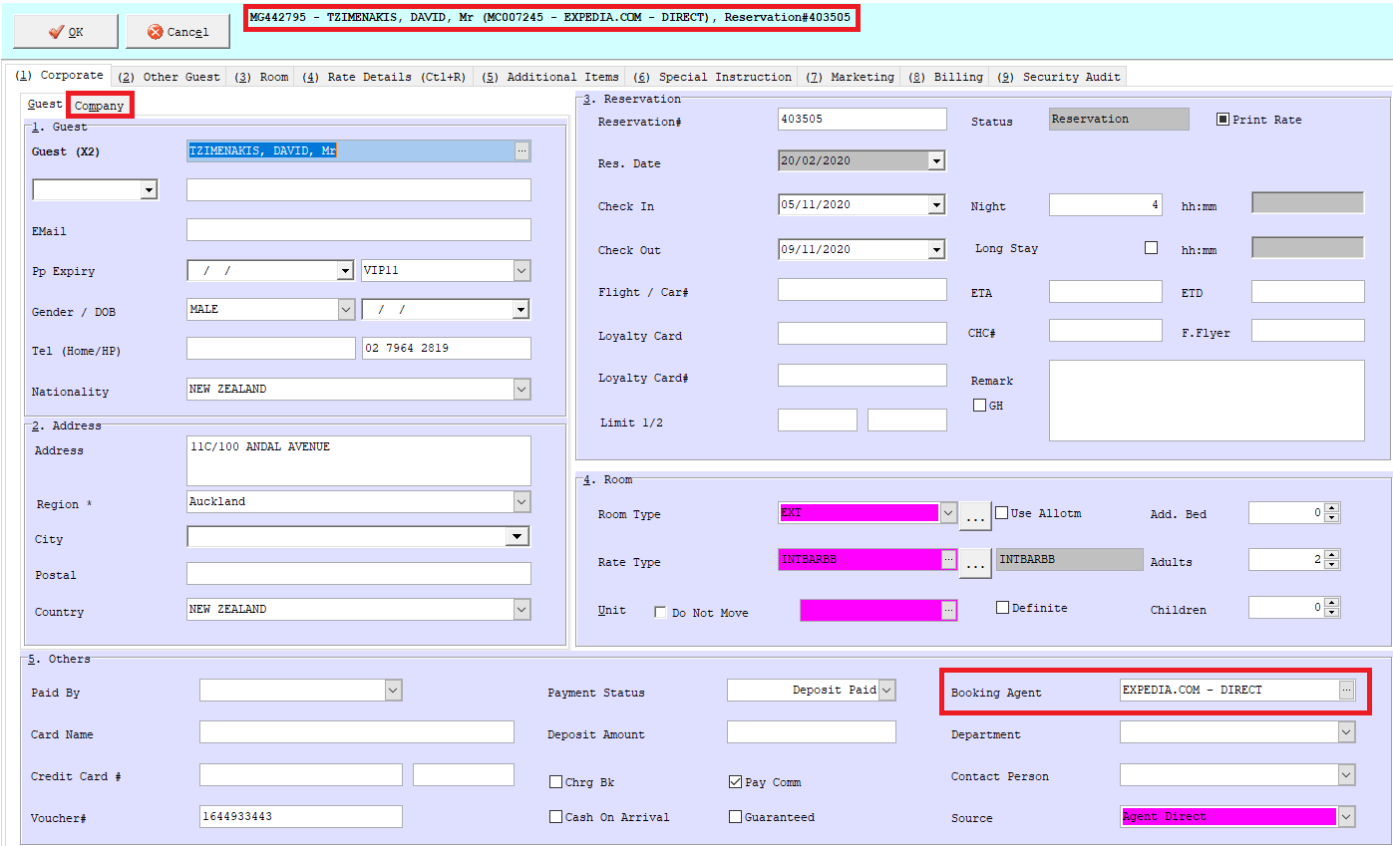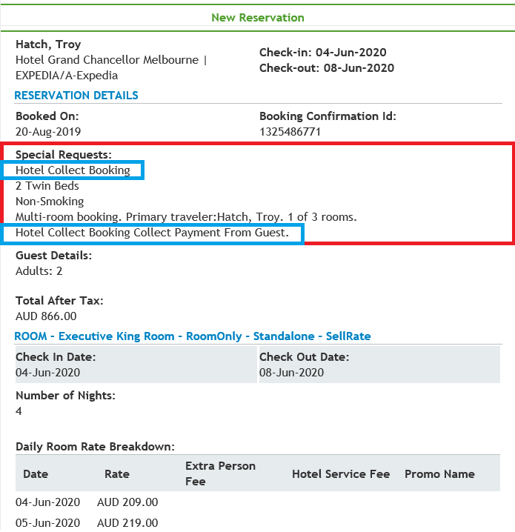

**Updating an OTA Booking**

**Expedia.com**

Rollaway Instructions

* If there is a rollaway included, it will show as an additional charge. Must add this to nightly rate and enter into HMS manually as **one.**

Example if **Room Only** Rate:

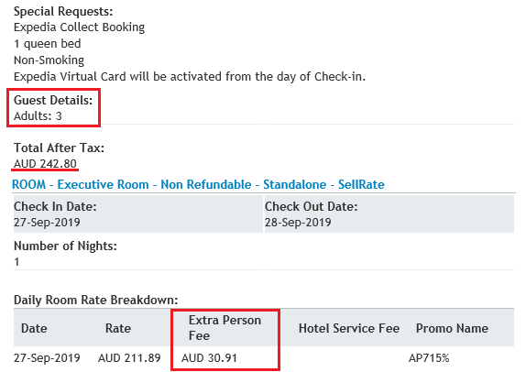

* Rate = $211.89 + 30.91 = **$242.80**
* Must add *‘Roll incl.’* into Additional Items and change amount to $0
* Special Instructions:

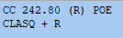

Example if **Breakfast & Rollaway Included** Rate:

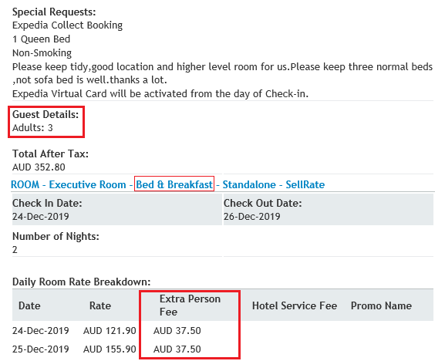

* Rate: $121.90 + 37.50 = $159.40

$155.90 + 37.50 = $193.40

TOTAL = **$352.80**

* Must add *‘Roll inc’* into Additional Items and change amount to $0
* Special Instructions:

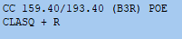

**Updating an OTA Booking**

**Qantas/Hooroo/Jetstar**

* All bookings will supply VCC therefore, payment instruction will always be CC. Booking itself will be saved as paperwork to be charged on check out date. Save on M Drive > Reservation Chargebacks > Year > Month > Date of check- in. Save it with guest’s last name & folio number.
* Below is the important information to look at:

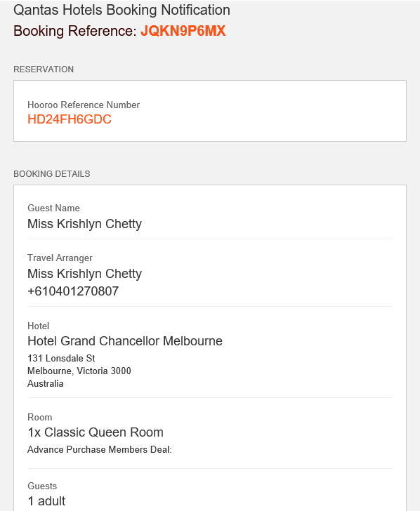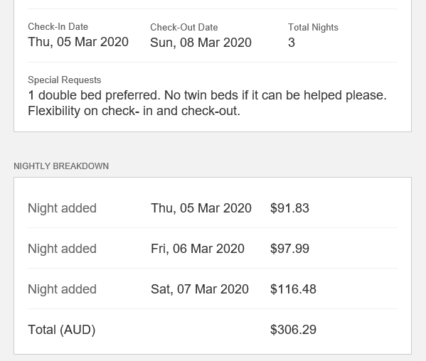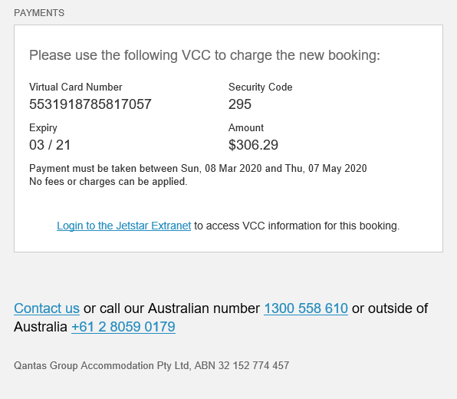

# Guest requests

# Cancellation Policy

# 

# Room Type

# 

# &

# 

# Rate Breakdown

# VCC Details

# Guest’s details

**Updating an OTA Booking**

**Flight Centre**

* All bookings’ payment instruction will always be DBA. Booking itself will be saved as paperwork to be D-billed on check out date. Save on M Drive > Reservation Chargebacks > Year > Month > Date of check- in. Save it with guest’s last name & folio number.
* Booking Number to be updated on HMS under Voucher#
* Below is the important information to look at:

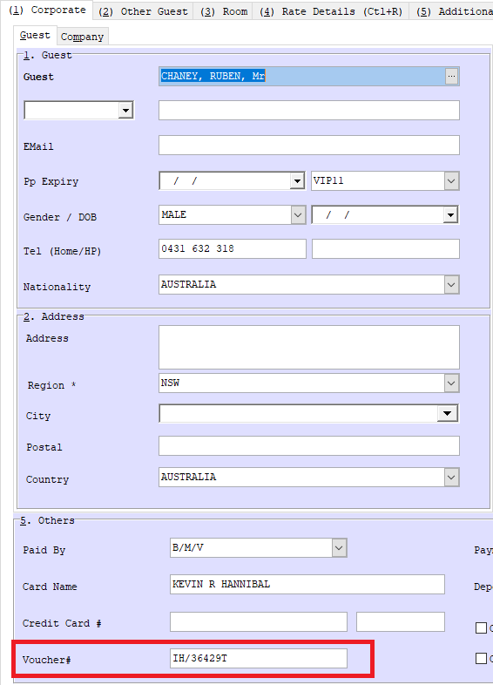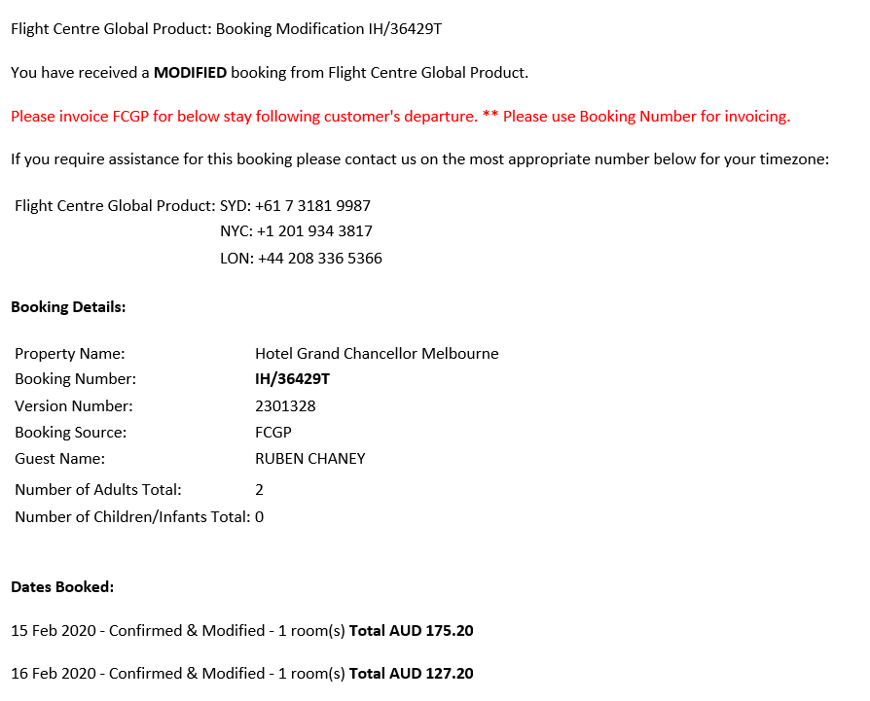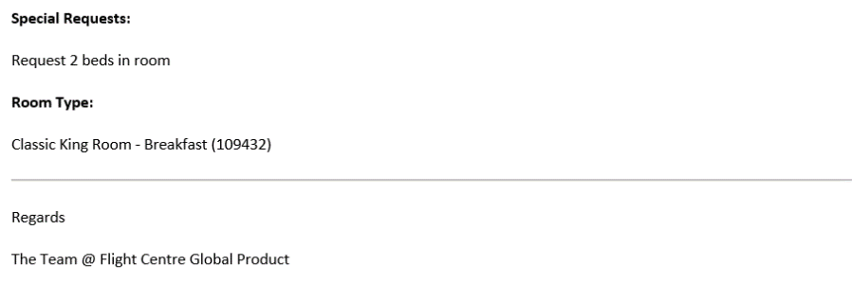

# Guest Requests

# Room type / Inclusions / Cancellation Policy

# Voucher Number

# Number of Guest

# Rate Breakdown

**Updating an OTA Booking**

**Hotelbeds/Travelcube**

* All bookings’ payment instruction will always be DBA. Booking itself will be saved as paperwork to be D-billed on check out date by FO team.
* Booking Agent to be updated to **TRAVELCUBE PACIFIC PTY. LTD.**
* Update Marketing Segment on tab (7) Marketing to ‘Inb Fit’
* If booking indicates 2 beds, manually update room type to either EXT or SXT on HMS
* Below is the important information to look at:

# Guests’ Request /

# Bedding Configuration

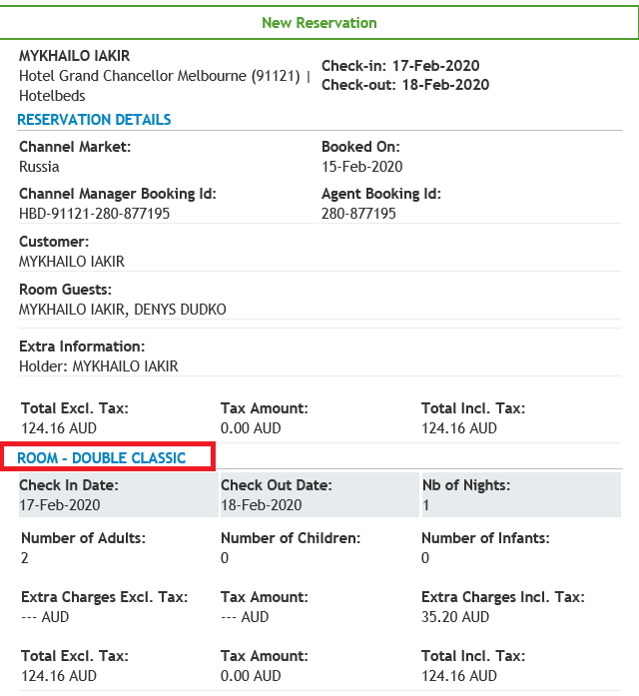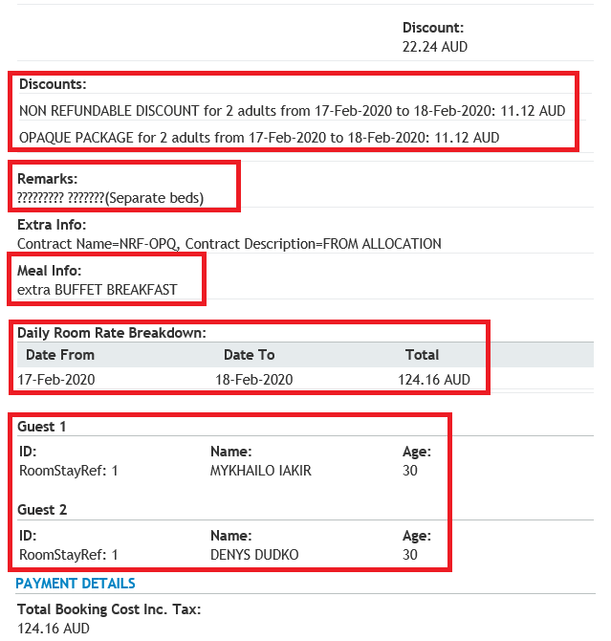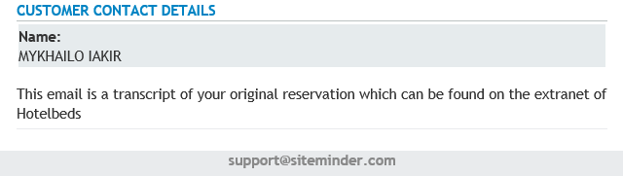

# Room Type

# Cancellation Policy

# Breakfast Information

# Rate Breakdown

# Staying Guests’ Names

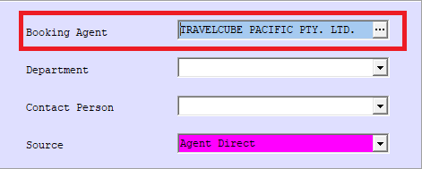

**Updating an OTA Booking**

**Revato**

* Non-Refundable bookings must be charged on the same day of booking and payment method will be PP. Obtain CC details via Siteminder by using booking reference #.
* Add-Ons/Extras needs to be added under tab **(5) Additional Items** with correct rate.
* Below is the important information to look at:

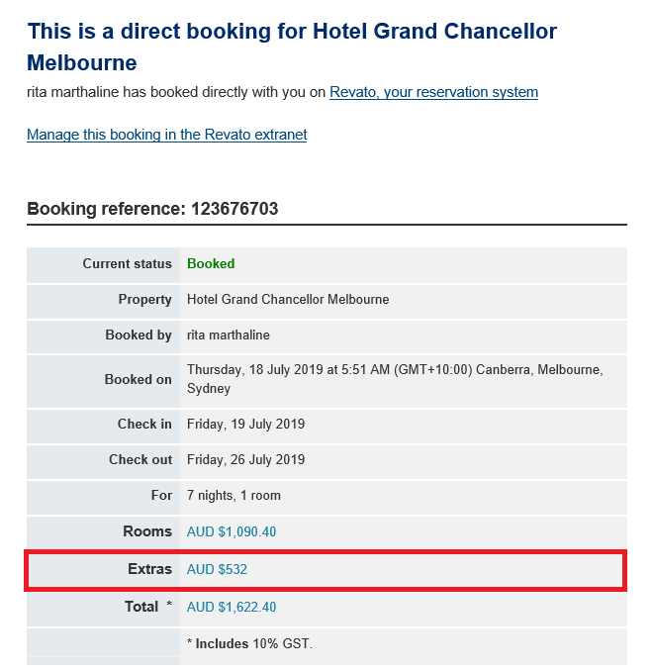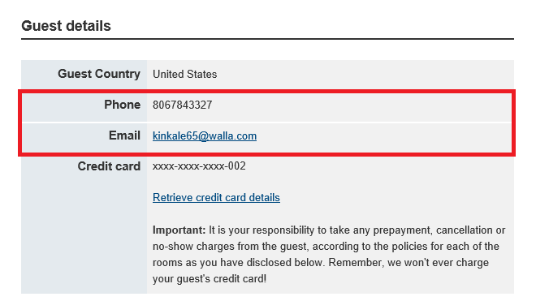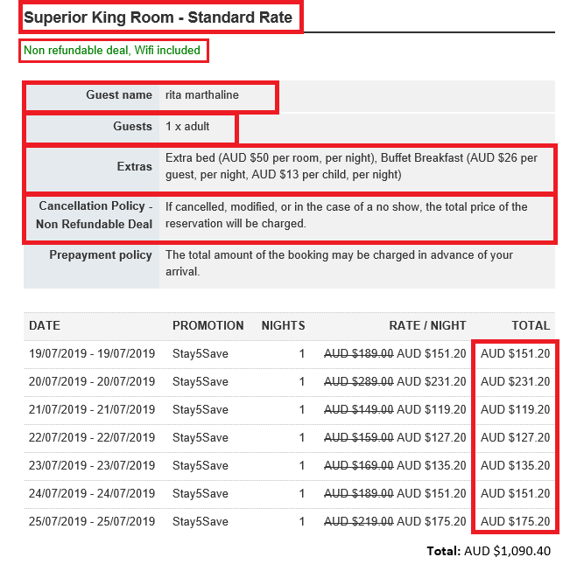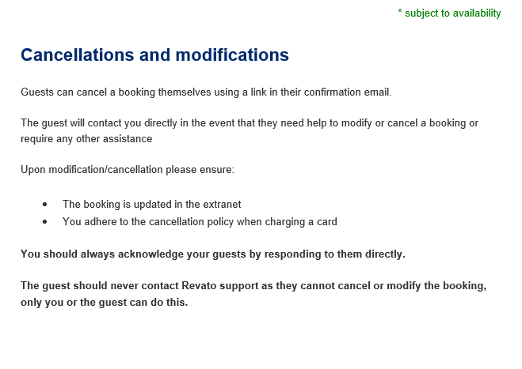

# Room Type

# Cancellation Policy

# Add-Ons

# Number of Guests

# Cancellation Policy

# Guests’ Contact Details

# Add-Ons’ total fee

# Rate Breakdown

# Guest Name

**Updating an OTA Booking**

**Things to Remember:**

* If a reservation is for “**Executive King / Superior King**” – read the ‘Special Requests’ to see if guest requires 1 King or 2 Single. If nothing stated, this will automatically be considered King bed. If requested for 2 Single, please add “split” on the Additional Items tab on the booking.
* HotelBeds/Travelcube bookings only have the option to select ‘Classic’ or ‘Superior’. If the booking states twin / separate beds / 2 beds request, please manually update room type to EXT or SXT for no extra charge.
* If booking received is for multiple room, ensure to link these bookings together by writing how many rooms and the folio numbers of each room on every remark page in HMS. This is to assist FO Duty Manager to assign rooms together or at least close to each other. See below sample:

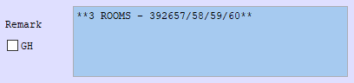

* Ensure to add any guest requests provided in the booking on Additional Items Tab on HMS. Update rate accordingly if request has a corresponding fee and ensure this add on is also added on check in instruction. Any requests that are not available to add on Additional Items tab should be mentioned on the remark section.
* Any Booking.com bookings received or made on same day of arrival; NO PAYMENT is to be taken prior to guest arrival (regardless of rate type booked). Payment method for these bookings will be updated as POA and **SAME DAY BKG** notes needs to be added on remark section on HMS to advise FO on guest check in.

**Updating an OTA Booking**

* If guest staying is known to be under a specific company that has contracted rate with us, update company with guest’s company and update rate code accordingly to the cancellation policy of the booking. Ensure to add on remark section ‘**NO INCLUSIONS**’ to inform FO that booking was not made directly with company’s contracted rate and so they can also advise guest upon check in to avoid confusion. See below sample:

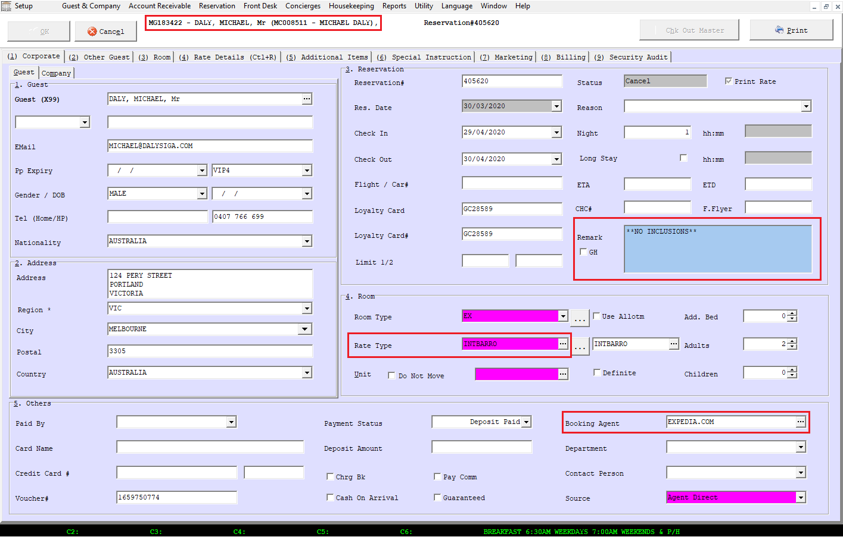

Above booking was for Mr. Michael Daly who has a contracted rate with us under Michael Daly Company. But because the booking was made through Expedia (refer to booking agent), rate booked doesn’t have the inclusions he gets on company contracted rate. Rate type will be updated according to the cancellation policy of the booking and ‘NO INCLUSIONS’ note had been added to remark section.

**Updating an HGC Website Booking**

* Locate the booking on HMS by typing guest name
* Once located, ensure to read and understand carefully the booking before updating HMS. Below is the important information to look at

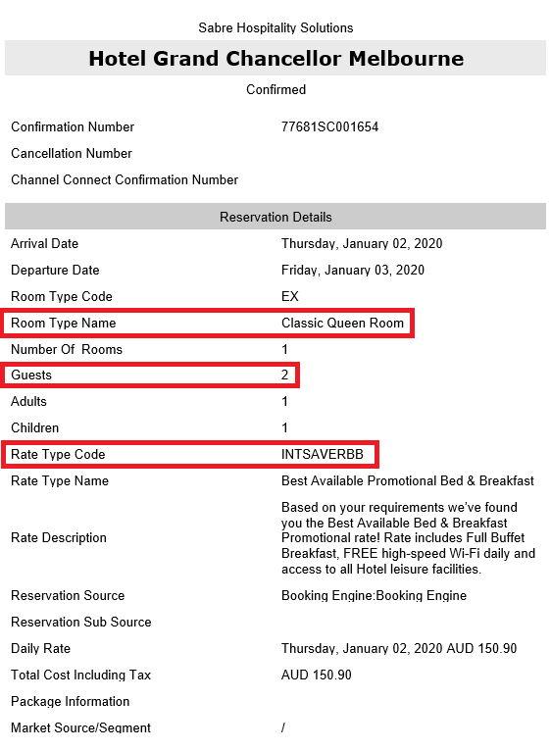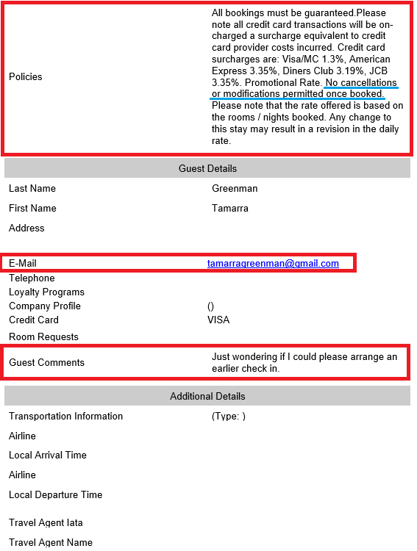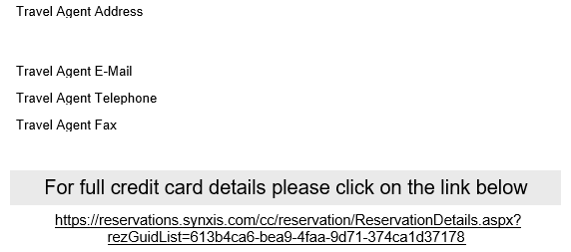

# Room Type

# Number of Guest

# Rate Code

# Rate Breakdown

# Cancellation Policy

# Guests’ Details

# Guests Requests

This shows that booking was made on HGC Website

**Updating an HGC Website Booking**

# Update BOTH Company Name & Booking Agent to HGC WEBSITE

* Bookings done directly to hotel/website doesn’t require prepayment therefore, payment instruction will always be POA.
* Update Market Segment on tab (7) Marketing accordingly

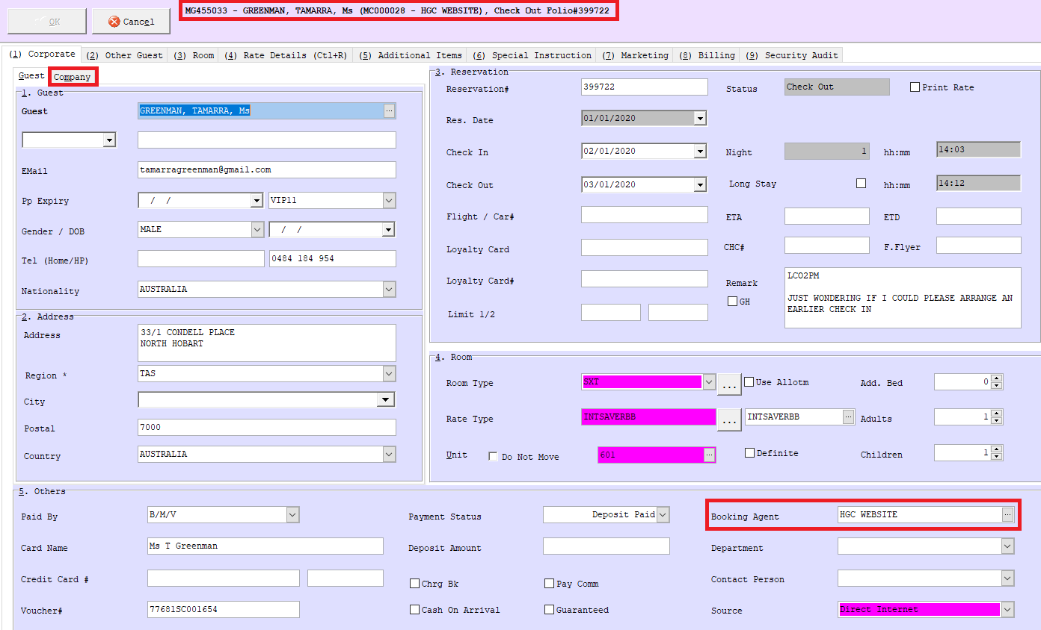

* If the booking is for 3 Adults, the Rollaway Fee is included in the nightly rate. Must add ‘Rollaway Incl’ in Additional Items:



* 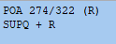Special Instructions:
* If booked for 2 adults and 1 child, the rollaway bed is **not** included. If the guest requests a rollaway, they have to pay an additional $40.00 per night (Room Only).

**Updating SynXis Booking**

**Corporate Bookings**

* Locate the booking on HMS by typing guest name
* Once located, ensure to read and understand carefully the booking before updating HMS. Below is the important information to look at:

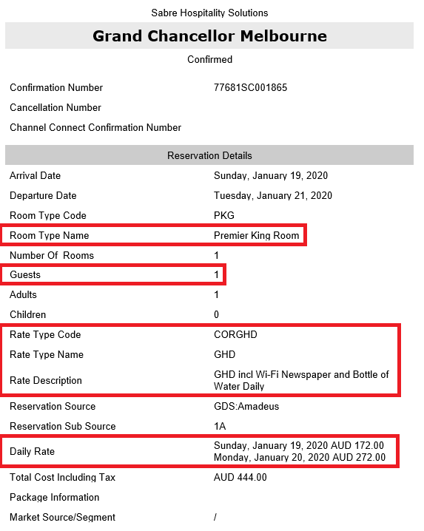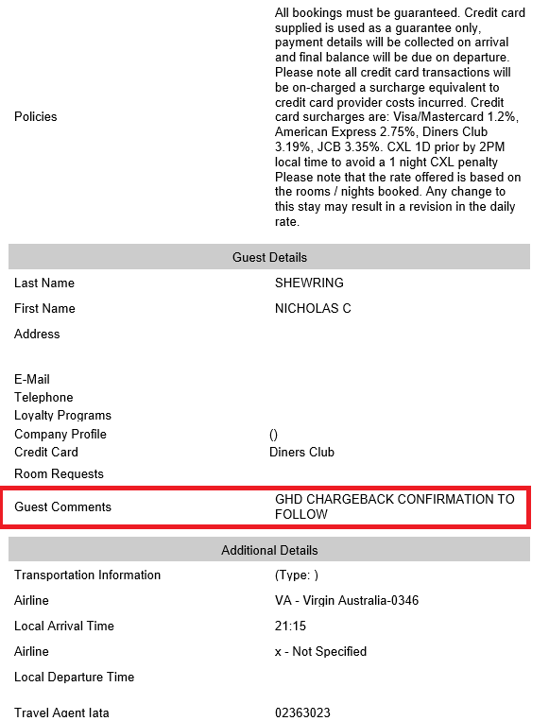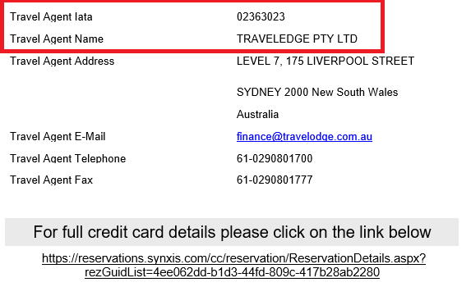

# Room Type

# Number of Guest

# Company Name /

# Company Rate Code /

# Rate Inclusions

# Rate Breakdown

# Guests’ Requests /

# Chargeback Instruction

# Booking Agent Details

**Updating SynXis Booking**

* Update Company Name, if not listed on booking or company has no negotiated rates insert Travel Agent’s IATA number from the booking
* Update Booking Agent by searching using Travel Agent IATA
* Update Rate Code
* Ensure inclusions are added on check in instructions
* Chargeback normally drops in after the booking confirmation however update payment instruction to AA if no chargeback received yet. Update check in instruction accordingly to the chargeback received.

**Updating SynXis Booking**

**GDS Bookings**

* Locate the booking on HMS by typing guest name
* Once located, ensure to read and understand carefully the booking before updating HMS. Below is the important information to look at

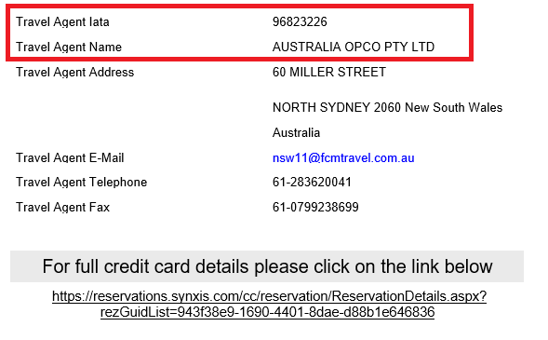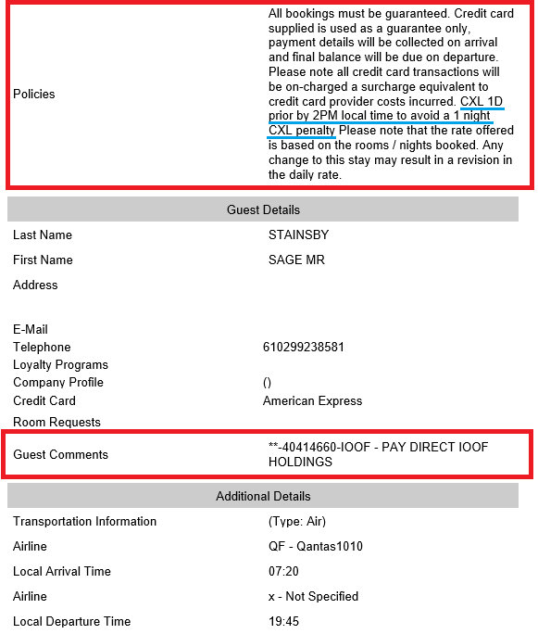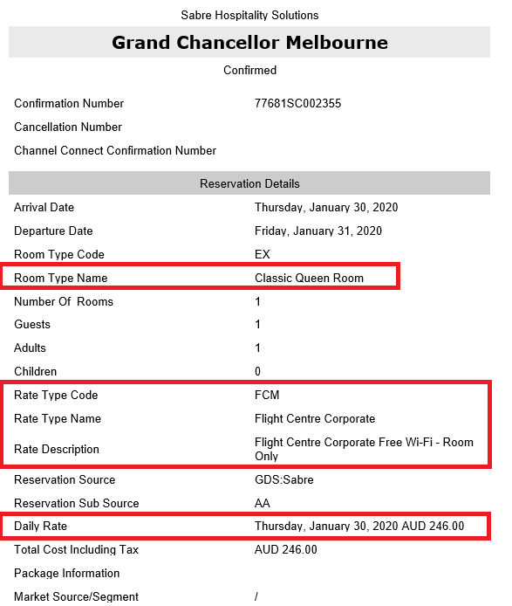

# Booking Agent Details

# Guests’ Requests /

# Chargeback Instructions

# Cancellation Policy

# Rate Breakdown

# Rate Code /

# Company Name /

# Rate Inclusions

# Room Type

**Updating SynXis Booking**

* Update Company using Travel Agent **IATA**.
  + If guest is a return guest and company is loaded on profile, use guests’ company.
  + Update booking Agent with the IATA Number listed on the booking.
  + Chargeback sent for booking will also indicate guest’s company. If company has negotiated (C3/C4/CSpecial or Govt FIT) rates with us, update the company profile accordingly and leave booking agent as per IATA number.
* Update Rate Code
  + If GDS BAR, GDS Saver or consortia rate is booked corporate inclusions are not included in the rate.
    - Add ‘**NO INCLUSIONS**’ on Remark section of the booking on HMS (Update company details if known)
  + Choose GDS BAR (if with cancellation) or GDS SAVER (if no cancellation permitted)
* Update Booking Agent by searching using Travel Agent IATA

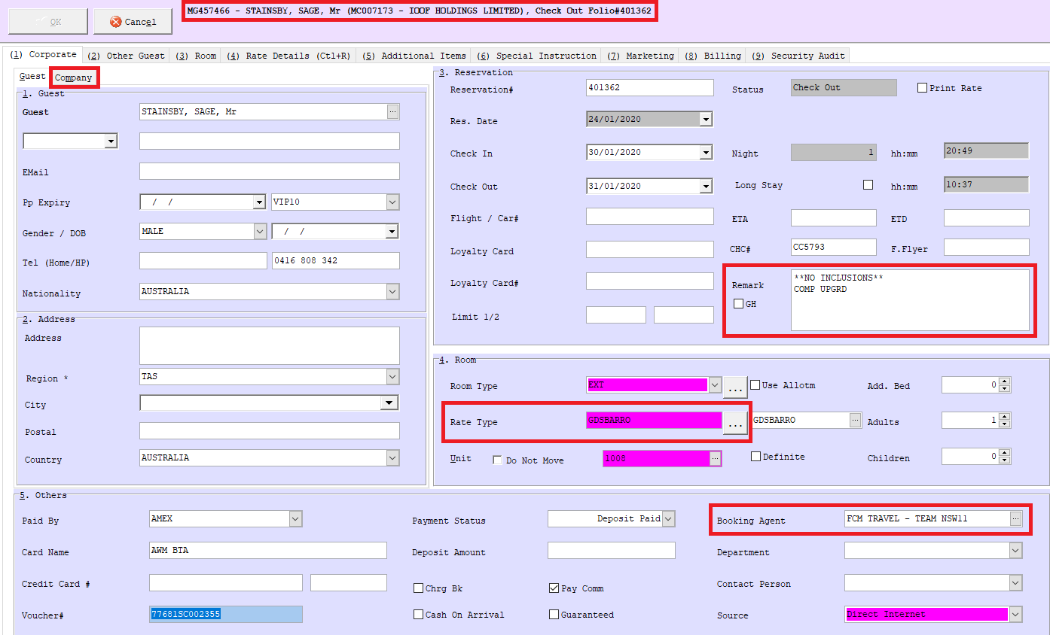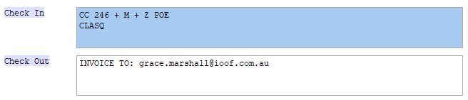

**Updating SynXis Booking**

**Things to Remember:**

* If Travel Agent IATA/Travel Agent is not yet in the system, create a new company. Fill up the details accordingly with the Booking Agent Details provided on the booking.
* Add Company’s Chancellor Club Number under CHC# every time updating/creating booking. Chancellor Club Number are located in company’s profile under Remark on tab (2) Others.
* Add chargeback restrictions including email details for tax invoices under Check Out Instructions.

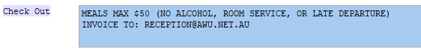

* If booking is entitled to BTP Program, ensure to add on to Check In instruction ‘BTP’ to notify FO when checking in guest. See below sample:

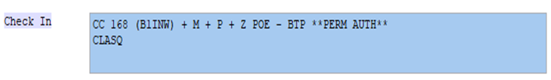

**Promotions**

Updated promotions are available at:

M Drive > Operations > Reservations > Promotions & Calculators > Promotional Calculator

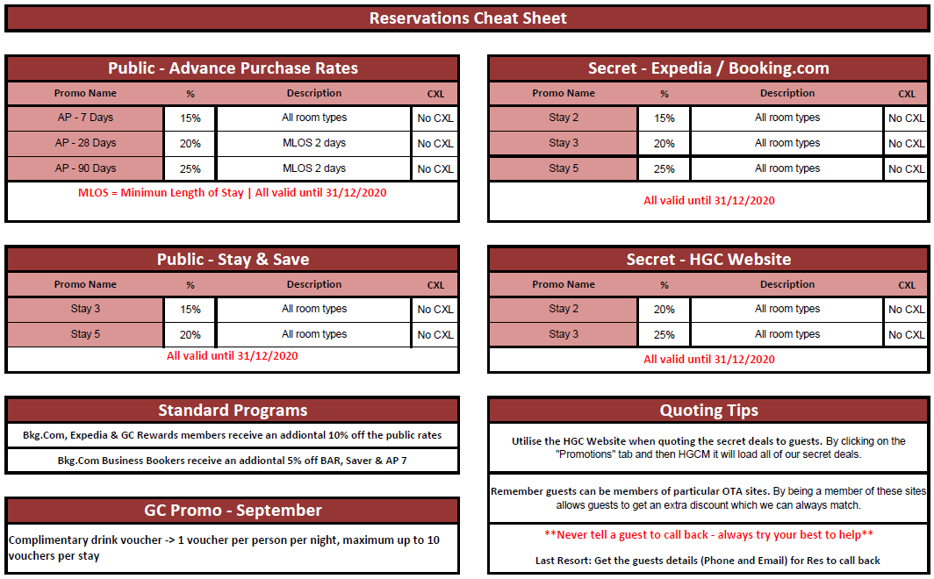

**Business Travel Partner (BTP) Program**

The BTP is exclusive to HGCM and offers corporate guests/companies added benefits for booking with us directly. Please see below all inclusions:

* Availability and access to a fixed Business Travel Rate year round
* Best Rate Guarantee
* Breakfast for one person daily - Add breakfast for second person for just $22.00 per person per day
* (Retail Price $29.00)
* High speed in-room Wi-Fi
* Bottle of still water daily
* Australian newspaper
* 10% Food & Beverage discount when dining in Encore Restaurant & Bar
* Every negotiated corporate guest receives a complimentary standard drink per stay at Encore
* Restaurant & Bar
* Book any event and the facilitator will receive a complimentary room upgrade to a Premier King
* Room
* Discounted Car Parking rate at V.I.P. Car Park at $30.00 per night (Retail Price $35.00) *

*Car parking space is strictly subject to availability, and spaces cannot be reserved in advance.

Additional Benefits

* No annual minimum room night requirement – we just want to reward your loyalty!
* Best Rate Guarantee – your contracted rate is the most you will pay. Should you find a lower rate
* promoted at Hotel Grand Chancellor Melbourne in the same room type we’ll match it and also keep
* your benefits (includes promotional rates)!
* Loyalty Programs – earn points and benefits for staying with us
* Rates are available for personal use
* Rates are available to subsidiary companies

The following exclusions apply:

* Shipping company guests are NOT entitled to the Encore discounts NOR the complimentary drink voucher – that is Inchcape, China Navigation Company (Swire), Borthwick Maritime Services and Gulf Agency Company (GAC).
* Government guests are NOT entitled to the complimentary drink voucher (e.g. DHHS)

**Inbound Bookings**

Inbound bookings are normally received through reservations email. It can easily be recognised through the inquirer’s company through email signature if company profile has not yet been added on the system.

Inbound have different rates from OTA & Corporates, and this are updated yearly and are categorised into two – Low Season (April-September) & High Season (October-March). Below is a sample inbound rate for 2020-2021:



**Quoting Rate for Inbound Booking**

Step 1: Check availability on HMS and rate restrictions on 396 Day Load document. Ensure to apply corresponding surcharge if date required falls on special event. Ensure to consult with DORSM for dates that has low room availability to avoid overbooking and for dates marked with special comments.

Step 2: Check inbound rate. If date required is within special events period, compare inbound rate with surcharge to rate advertised online - seek approval from DORSM before offering rate.

**Group Booking**

Booking groups are not only limited to Inbounds. Private, Corporate and Conference attendees’ bookings can be booked as group booking if it requires 4 or more rooms.

**Creating a Group Booking**

Step 1: Press Alt + G or click 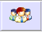

Step 2: Fill up necessary information and click next:

* Company – locate if company details are already in system. If company already in system, check if there is an account open for payment purposes.
* Group Name – usually will be provided by booker on initial inquiry.
* Check-in date & Check-out date
* Rate type
* Contact Person – name and contact details of booker
* Number of rooms to be booked.

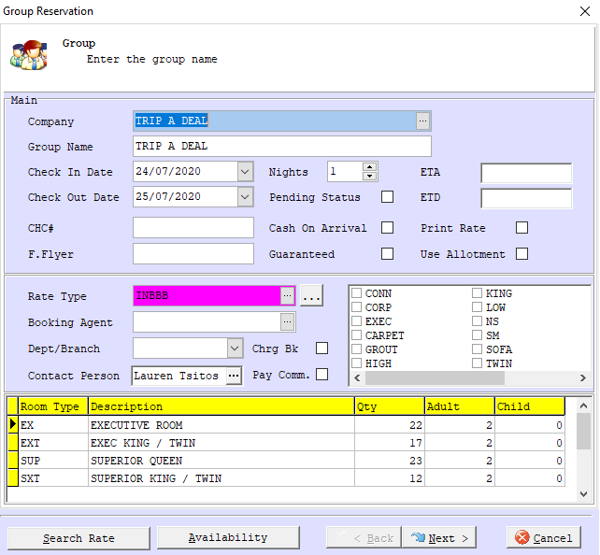

**Group Booking**

Step 3: Click Next. Adjust Mkt Seg 4 to Inb FIT or Inb Group depending on the number of rooms booked.

Step 4: Update Check-in Instructions

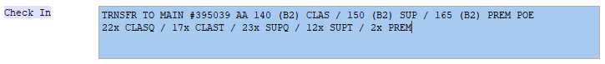

Step 5: Create task as reminder for FOC cancellation and follow up payment

* To create task, on tab (6) Special Instruction under Messages, right click and Add Message. Or, on folio, right click and choose Add Message
* Fill up necessary information:
  + Type – always change to task
  + Status – Open
  + To – choose the department that will be actioning this task
  + Date – the date this task needs to be actioned/followed up
  + Message – where instruction/reminder will be briefly added

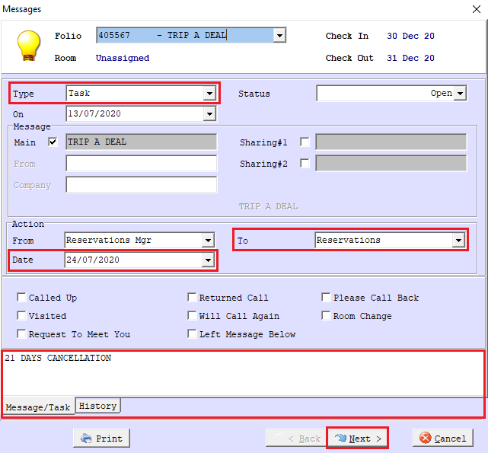

**Group Booking**

* To check if task was successfully created, folio should show 



Step 5: Create group invoice to be sent along with the confirmation if accommodation is still yet to be paid.

* Invoice template can be found in *M:\Operations\Reservations\Groups Invoice and Cover Sheets* with file name ‘Group Tax Invoice Template’
* Fill up necessary information and save document as excel and pdf file on *M:\Operations\Reservations\Groups Invoice and Cover Sheets\GROUP INVOICES*

Step 6: Send confirmation to booker and ensure to attach group invoice and hotel bank details on confirmation email for remittance purposes.

* Hotel bank details can be accessed at *M:\Operations\Reservations\Groups Invoice and Cover Sheets* with file name ‘BANK DETAILS’

**Loyalty Program Redemption Booking**

Redemption bookings are usually received from Grand Chancellor Loyalty department. However, GC & CC Members can directly inquire and book through the hotel.

Useful links are below to collate member’s information:

GC Rewards: <https://www.ghihotels.com/GC_Admin/Login.aspx>

CC Rewards: <https://ghihotels.com/booker_Admin1/Login.aspx>

* Log in details can be accessed at: *M:\Operations\Reservations\3rd Party Logins*

**Redemption Chargeback**

 Can be accessed at: *M:\Operations\Reservations\GC REWARDS*

**Loyalty Program Redemption Booking**

**Creating Redemption Booking**

Step 1: Check if date requested is not within the GC blackout dates on 396 Day Load.

Step 2: Check room availability on HMS.

Step 3: If guest/member is booking directly, check if they have enough points to redeem.

Step 4: Create booking by clicking  and filling up necessary information:

* Guest Name - ensure guest profile is updated with their information. Create new profile if not yet in system and input guest details from the link above.
* Company Name - should only be either GC REWARDS REDEMPTION or CC REWARDS REDEMPTION.
* Check-in & check-out dates
* Number of pax staying
* Rate type - depending on the redemption that the member chose – room only, breakfast, or breakfast with 3 course dinner
* Contact Person – name of loyalty team member that made the booking

Step 5: Provide folio number to the loyalty department member.

* If guest made the booking directly to the hotel, advice that booking confirmation and voucher will be sent by rewards redemption department. Ensure to email to advise booking had been made and provide necessary information such as guest name, date of stay, room type and inclusions, and folio number for them to issue voucher and adjust points to guest’s membership profile.

Step 6: Save voucher on chargeback folder and add voucher number on booking once received.

**Chargebacks & Payment Authorisation Forms**

**Credit Card Authorisation Form**

This form authorises the hotel to use the credit card that can’t be physically supplied upon check in or the credit card that is not owned by the guest. The following are required to be provided to the hotel along with the completed credit card authorisation form:

* Copy of valid photo ID of the card owner
* Front and back copy of the nominated card

**Permanent Authorisation Form**

Form offered to corporates that wishes to use the same payment method for every booking that they made. This is to save time providing credit card authorisation form for every booking made.

Permanent Authorisation Forms are valid from the day that it has been provided to the hotel until the end of the year. Permanent Authorisation Forms are needed to be updated yearly even if the credit card supplied is not yet expired.

**Credit Application Form**

This form is provided to companies who request to set up an account with the hotel. This will be handled by accounts team and accounts team processes invoices and chase up payments from company.

Once company’s credit had been set up, check in/payment instructions will automatically be DB unless advised upon making the reservations. Company can also provide permanent authorisation to use the credit facility for every booking made.

Chargeback can be accessed and saved at *M:\Reservation Chargebacks* along with the other chargebacks received from OTA bookings

Credit Card Authorisation & Permanent Authorisation forms can be accessed at: *M:\Operations\Reservations\Payments - Forms & Details*

Remember:

* Credit card authorisation form must be supplied to the hotel prior to or upon guest arrival along with the other requirements to be able to use it. Full accommodation fee and bond will be required to be provided by the guest on their own credit card before issuing keys if authorisation form has not yet been received.
* Name, signature and credit card details should all match before accepting authorisation form.

**Cancelling a Booking**

Step 1: Locate the booking in HMS by typing guest name or folio number

Step 2: Right click on the booking and Cancel Reservation

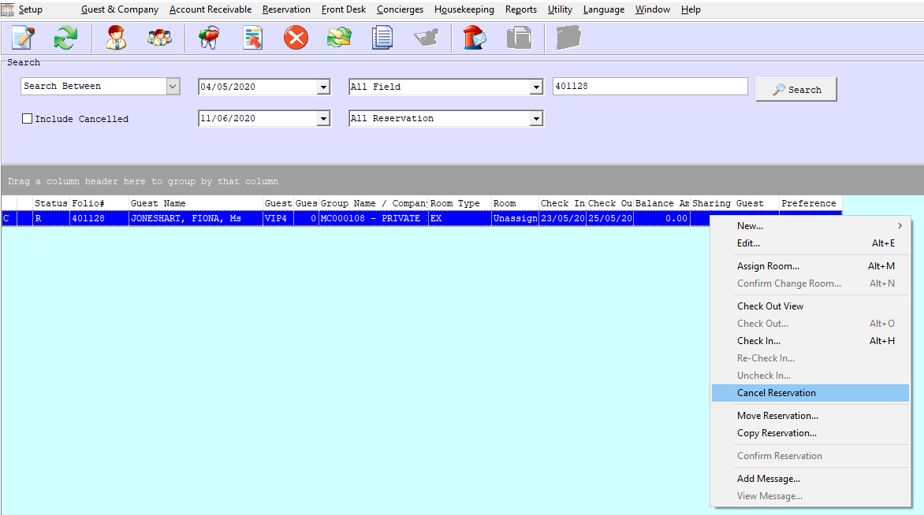

Step 3: Fill up necessary information on the Cancellation pop up window.

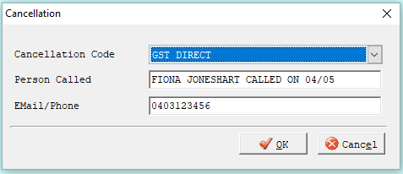

Step 4: Click Ok and booking will be cancelled in the system.

**Cancelling a Booking**

**Policy:**

BAR Rate:

* Cancellation must be made 1 day prior to arrival day by 2pm, or 1 night’s accommodation will be charged

SAVER/Promo Rate:

* No cancellation or amendment permitted

Corporate Bookings:

* Cancellation must be made by 2pm on the day of arrival, or 1 night’s accommodation will be charged.
* Cancellation must be made 1 day prior by 2pm local time to avoid 1 night’s accommodation penalty.

LIDO Government Bookings:

* FOC cancellation until 5pm on the day of arrival

**Things to Remember:**

* OTA bookings usually cancel automatically on HMS once cancellation email had been received except for Qantas/Hooroo/Jetstar and prepaid bookings (that has been approved by Reservations Department/Duty Manager after processing payment).
* No OTA bookings to be cancelled unless cancellation email received.
* Read carefully each cancellation email received and action accordingly. Make note on remarks section for any important information regarding cancellation and process refund if necessary.
* Ensure to close any opened task before cancelling the booking.
* GDS Promo bookings will not allow agent to cancel at all. If agent/booker advised they cancelled it prior, advise of cancellation policy and cancellation made from their end will not be received by us due to cancellation policy.
* Always put in the name, contact number and date of email/call when cancellation was made for future reference.

**Registration Card**

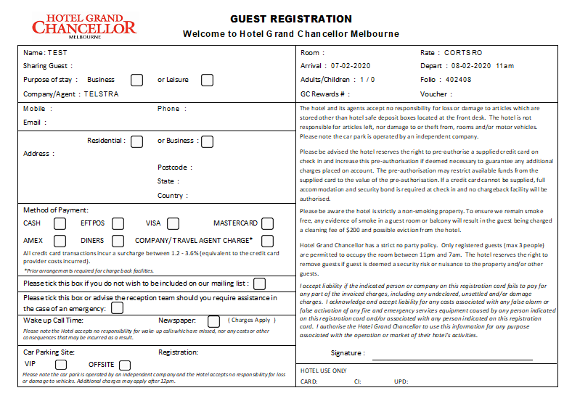

**Pre-Authorisation**

Pre-Authorisation is a request from a merchant to a card holders bank to hold funds on a credit/debit card, in anticipation of a potential future charge. This should be processed whenever there is an unknown final transaction to be processed such as a guest staying in a hotel that may incur incidental fees like the use of the minibar and other income generating facilities (Room Service, Laundry, PPV Movies, etc.).

Preauthorisation allows the hotel to verify that sufficient fund is available (to cover the estimated amount of charges for his/her stay) on a guest's credit card, and reserve the funds if available. The preauthorised fund is only blocked, and not charged to the credit card. This is necessary so that the hotel has a guarantee of the guest ability to settle their bills at the end of their stay. Upon check out, the hotel will perform another transaction to charge the card using the "blocked" funds. This will also release any difference between the preauthorised amount and actual bill amount. If the guest chooses not to pay the bill with the same credit card upon check out, the preauthorised funds will normally be released by the customer's bank within 7 days.

Any unused funds will not show as a refund; the pending transaction will be removed from the account. All pre-authorisations that are not used will be cancelled on the day of check out. Hotel reserves the right to increase the pre-authorisation if deemed necessary to guarantee any additional charges.

DHHS guests and bookings are no longer required to meet Pre-Authorisation policy requirements regardless if the booking is for personal stay or for work purposes. However, photo ID and pre-payment (for personal stays booking/POA bookings) will still be required upon check in.

**Commissions**

Commissions are done on a monthly basis. Some companies will send through their commission invoice and some OTAs, we will have to retrieve them from their respective extranets.

Commissions are for accommodation only. If company is also paying for meals, parking, etc., only accommodation rate will be commissionable.

Below is a rough guide on the percentage of commission companies’ charges per booking:

|  |  |  |
| --- | --- | --- |
|  | **Commission Percentage** | **Nett or Gross** |
| **Booking.com** | 15 | Gross |
| **Entertainment Card** | 5 | Gross |
| **Expedia** | 15 | Nett & Gross |
| **HotelBeds** | 25 | Nett |
| **Hotel Travel** | 13 | Nett |
| **HRS** | 15 | Nett & Gross |
| **Jetstar** | 13.2 | Nett |
| **Need It Now** | 15 | Nett |
| **Revato/HotelsCombined** | 13 | Gross |
| **FCTG** | 20 | Nett |

**Commissions**

**Corporate Bookings**

Checking the rate code can determine if the booking is commissionable or NETT.

Rate code that has ‘C’ on it is 10% commissionable. See below sample:







On the other hand, rate code that has ‘N’ on it are non-commissionable. Thus, booking must be marked NETT. See below sample:







Other companies that have their special rate code are non-commissionable therefore, will be marked as NETT:

* Woolworths
* Telstra
* Ixom

Other rate code that will be commissionable by 10% are:

* GDSBARBB
* GDSBARRO
* GDSPROMO

**Commissions**

**Government Booking:**

Please take note that the below rate code are 10% commissionable:

* GOVRO
* GOVBB
* GOVVICRO
* GOVVICBB







On the other hand, AOT Government bookings are non-commissionable hence, this must be marked as NETT:

* GOVAOTRO



**Commissions**

**Booking.com**

* Booking.com commission statement is available to retrieve every 3rd of the month. If this day falls on a weekend, send the statement to accounts team the following business day.
* Below are the steps to retrieve the commission statement:
  1. Log in to Booking.com Extranet
  2. Under Finance tab, choose Reservations statements
  3. To ensure you are retrieving the correct invoice, it will state that it has been issued on the 3rd month of the current month. See below example:

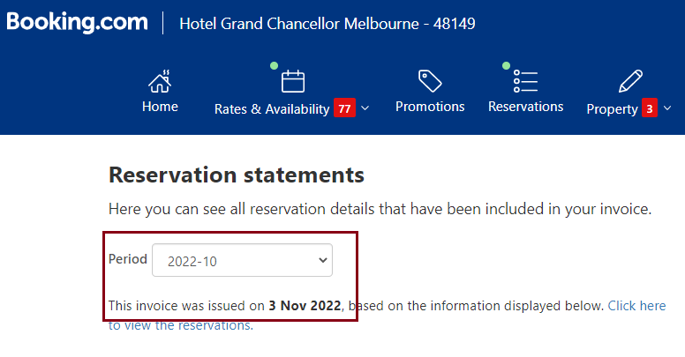

If invoice is not yet ready, the reservation statement page will look:

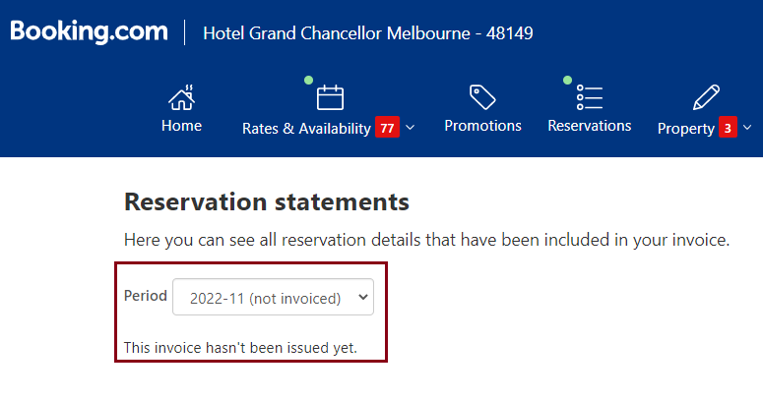

**Commissions**

* 1. Click Download XLS
  2. Send this document to accounts team
* Accounts team will send back the Booking.com Reconciliation list on an Excel Document with corresponding notes on each booking that needs credit. See below example:

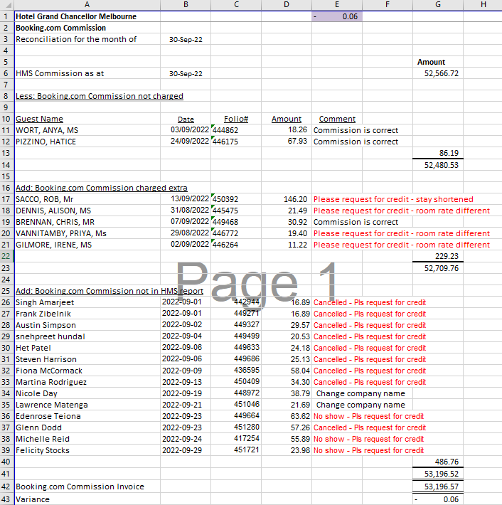

* Go through each booking on res email and compare the night of stay to the actual stay on HMS. Check the number of nights guest paid and not the date stated on the folio as sometimes bookings roll incorrectly and had to reverse accommodation.
* Investigate each booking as each credit note that will be requested will need reason/explanation.

**Commissions**

* To process credit request from Booking.com, follow the following steps:
  1. Log in to Booking.com Extranet
  2. Under Finance tab, choose Reservations statements
  3. 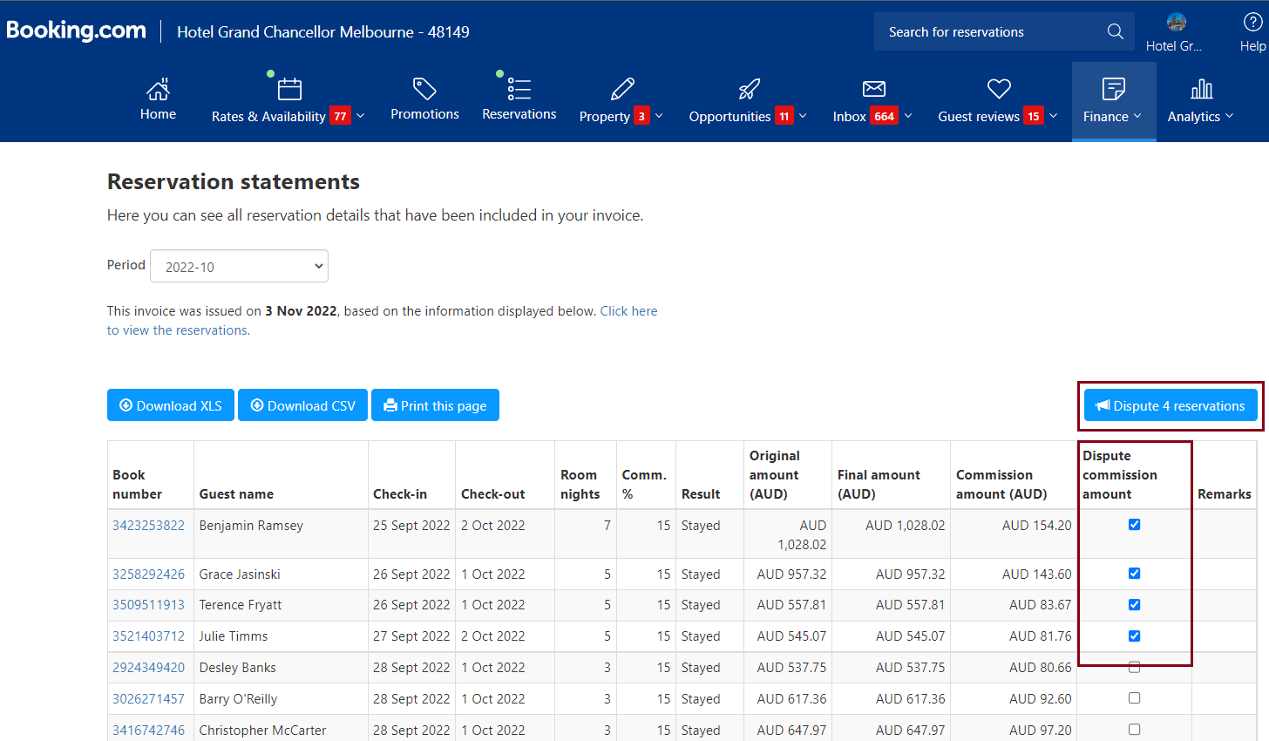Tick the box under Dispute commission amount column of each reservation that you need to request credit. On top right part of the page, it will show how many bookings you have ticked. Match this to the number of bookings you have from the excel sheet accounts sent.
  4. Once you’ve ticked all the box of the booking you will request credit, click dispute reservations 

**Commissions**

* 1. A pop-up window will appear which you will need to fill up accordingly depending on the reason you are disputing the commission.

Will automatically calculate depending on the amount on ’Amount paid by guest’. This amount needs to match the amount on the spreadsheet that account sent

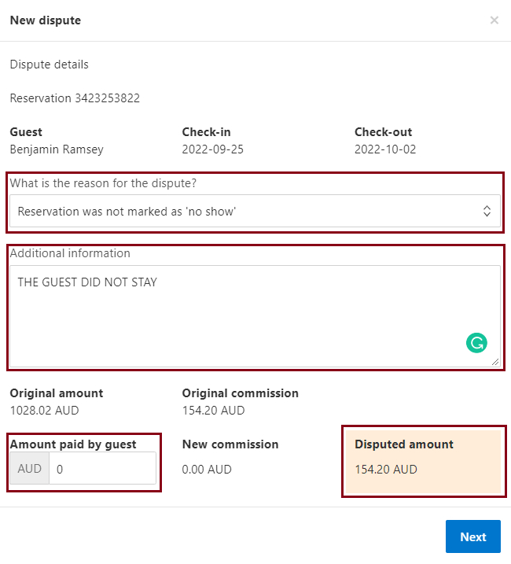

Update to the amount that the guest actually paid

* 1. Once all booking had been disputed, another pop-up window with the total a disputed amount. If total amount matches, click submit dispute.

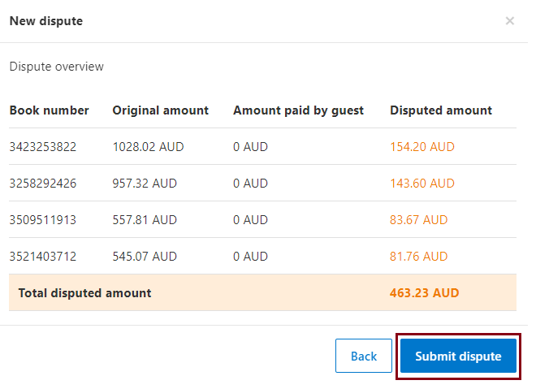

**Commissions**

**Expedia**

* There are two types of bookings under Expedia – Expedia Collect bookings wherein we receive VCC, and Expedia – Direct which guest pays directly to the hotel upon check in.
* Only Expedia Direct are commissionable bookings.
* Expedia reconciliation list needs to be sent to accounts team at least 5-7 days before 4th of the month as this is the deadline for their credit notes.
* To retrieve Expedia reconciliation list:
  1. Log in to Expedia Extranet
  2. Click Payments tab from the list on the left side
  3. Under quick task, click the link ‘Mark a Hotel Collect no-show or cancellation (reconciliations)’
  4. Click Export to spreadsheet located on the right top part of the list
  5. Send this spreadsheet to accounts team
* Accounts team will go through all the bookings on the spreadsheet and will email us back of the bookings we have to request credit note. This will be on an excel sheet as well.
* If this had been received before reconciliation deadline (4th of the month), this can be reconciled through the extranet:
  1. Go through each booking on res email and compare the night of stay to the actual stay on HMS. Check the number of nights guest paid and not the date stated on the folio as sometimes bookings roll incorrectly and had to reverse accommodation.
  2. Investigate each booking as each credit note that will be requested will need reason/explanation.
  3. 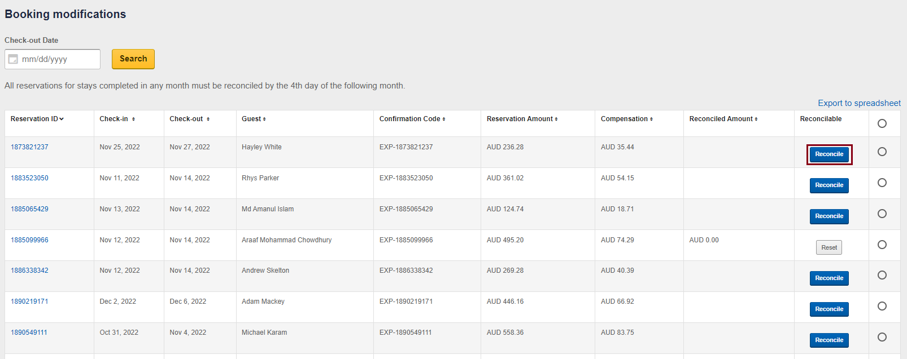On Expedia Extranet, click reconcile on each booking that we need to dispute commission

**Commissions**

* 1. Choose reason for reconciliation and update accordingly to the actual date stayed or the amount paid by the guest. Click Save and this will automatically adjust the commission fee. Maximum of 3 changes per booking can be made.

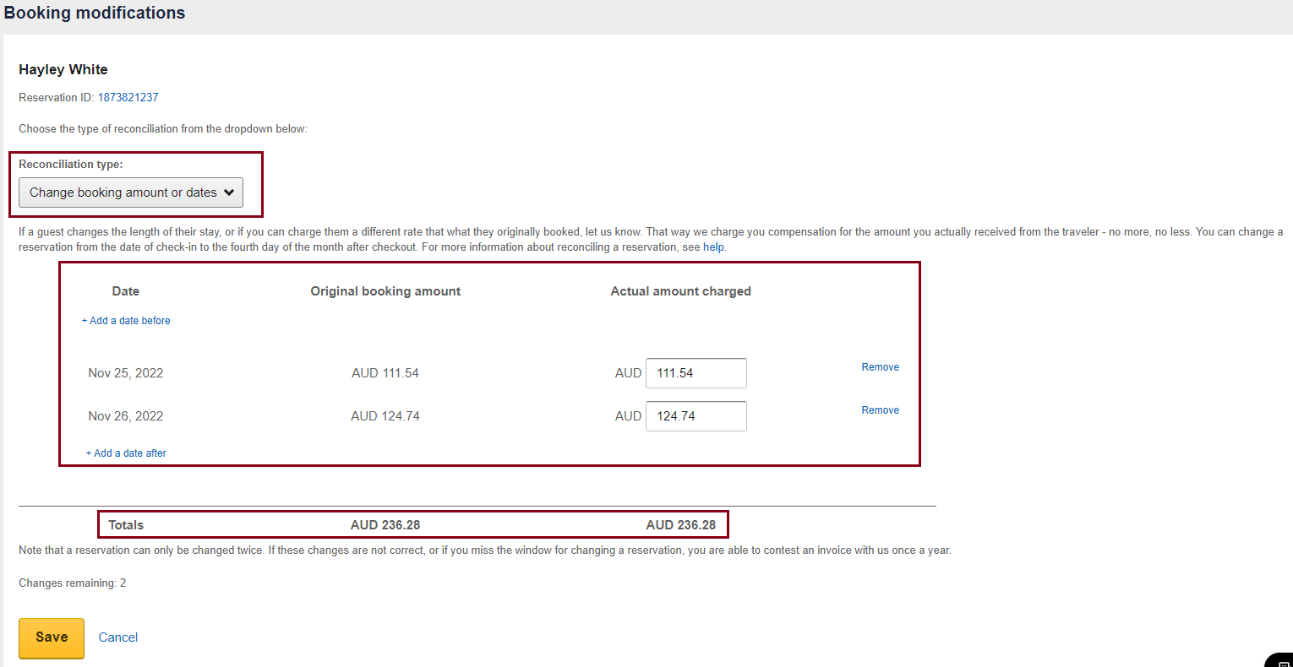

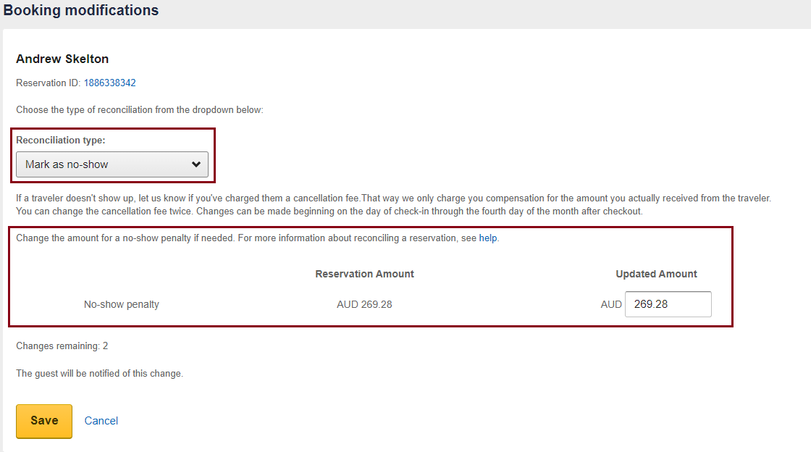

**Commissions**

* If accounts sent the spreadsheet after the reconciliation deadline, email a credit note request to [expediacollections@expedia.com](mailto:expediacollections@expedia.com). See below sample email:

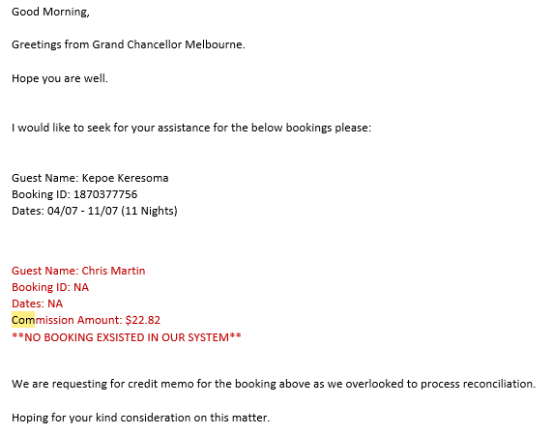

* Expedia will email back if credit request had been approved or not. Forward this email to accounts team to advise.

**Commissions**

**Nett Trans – (ONYX CENTRE SOURCE)**

* This commission list will be sent by Jana. Every email will have 2 different attachments – Statement sheet & Reminder sheet. Statement spreadsheet is the outstanding commissions of the bookings from the previous month. Reminder spreadsheet is an outstanding commission that already been issued to us prior but was marked not to pay yet.
* Not all bookings on this list will be paid. Each booking needs to be investigated and calculated.
  + 1. Open the spreadsheet of the commission you will be working on.
    2. Have a separate HMS open with dates adjusted to the stay dates of the bookings you’re going through
    3. Copy confirmation number from the spreadsheet and search it from the res email. If there is a cancellation email, mark this booking as CXXLD BKG straight away. Otherwise, proceed to step 4.
    4. Check Rate Code on the confirmation email. Some bookings are booked using their corporate rate and these rates are NETT or non-commissionable. Refer to page 66.
    5. Locate the booking on HMS, ensure you match the confirmation # to the voucher # on HMS. Confirm the rate code and if rate code loaded is correct, check if it is commissionable or not.
    6. If the booking is commissionable, check the payment on tab 4 of guest folio.

If accommodation had already been paid either by cash/EFT/CC, calculate the total and get the 10% of this. Match to the gross commission amount on the spreadsheet and mark ‘PAY’. If commission computed is less than the commission being invoiced, update the amount on the spreadsheet and highlight it accordingly. If commission being invoiced is less than the 10% computed, no need to update the price.

**Commissions**

If the booking is commissionable but payment is DBILLED, follow the below process to check if invoice had been paid already:

* + - 1. On HMS, click Accounts Receivable > Transaction
      2. Adjust the date to the date of the booking you’re going to check
      3. Add folio number to the search box next to the date and press search
      4. Under ‘Outstndg’ column, it will indicate if invoice had been paid (Fully Settled) or if it is still outstanding (amount will be in red font). See below sample:

Invoice not yet paid (total amount dbilled will be in red font)

* If booking is not yet paid, this will be marked ‘INV NOT YET PAID’

Invoice paid, ‘Fully Settled’ will be indicated

* If booking is fully settled, check if payment made is less commission already.
  + Right click the booking > Allocation History
  + Check the payment list and look for Travel Agent Commission
  + Mark as ‘Commission already been deducted from payment to us’
  + 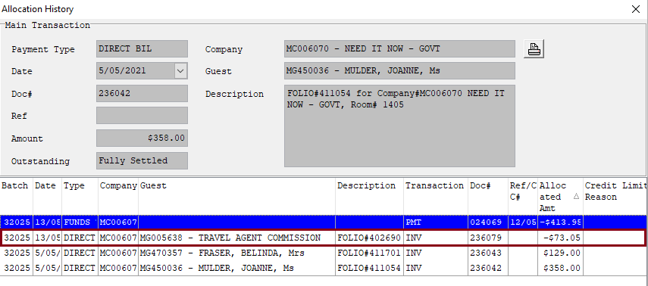Otherwise, mark booking ‘Pay’

**Commissions**

**Things to remember:**

* Please follow below colour coding when marking bookings on NETT TRANS:

|  |
| --- |
| PAY |
| NETT |
| INV NOT YET PAID |
| CXXLD BKG |
| Commission already deducted from payment to us |
| BKG NOT FOUND |
| *any other reason why we are not paying the commission* |
| OTA BOOKING |

* 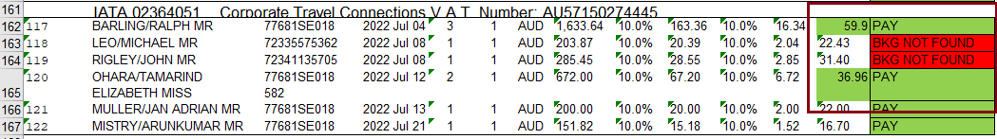Do not forget to highlight the commission amount if you have updated it with the correct amount
* Always check the rate code on the booking confirmation and not on the folio as booking is not always updated correctly
* If unsure, do not hesitate to ask Reservations Manager or DORSM to confirm if booking is commissionable or not

**Commissions**

**HRS**

* Payment reminder is normally sent to reservations email.
* To retrieve HRS commission invoice, open HRS Invoice Portal. Log in details is in the 3rd party log in details spreadsheet
  + 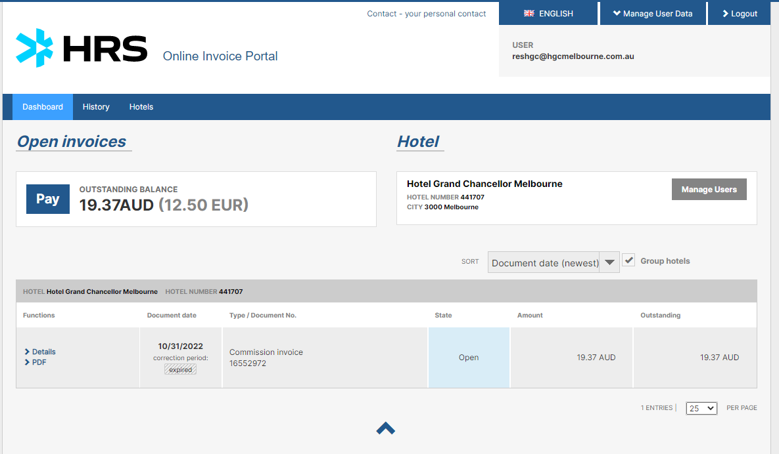Once logged in, you will see the list of outstanding commission invoice
  + Click the PDF link to download the commission invoice
  + Same procedure as other commission invoice, each booking needs to be investigated and calculated.
  + HRS commission is 15% per night booked for BAR Rates & Corporate Club Rates.
  + They also charge TAF fee of 2.50 Euro/night for a max of 5 nights per booking for NETT bookings, which had been approved by DORSM.
  + Once marked, email the commission invoice to accounts team
  + Hard copy needs to be dated, signed and placed on accounts payable pigeon hole

**Commissions**

**FCM & Other Commission Invoice**

* This will be emailed to reservations directly from the company.
* Same procedure as Nett Trans, each booking needs to be investigated and calculated.
* Ensure booking has not been invoiced to us already – to check, search the confirmation number on the res email. If commission invoice has already been issued, advise accounts team to avoid double payment
* Always print marked invoice, sign and leave it to accounts payable pigeon hole.
* Forward invoice to JANA/accounts team to advise that it has been done.